

P. O. BOX 1, KYAMBOGO – KAMPALA, UGANDA
Tel: +256 (0)414 289 707, E-mail: computing@scis.kyu.ac.ug Website: www.kyu.ac.ug

AN AI-BASED CONVERSATIONAL MENTAL HEALTH SUPPORT SYSTEM
CASE STUDY: STUDENTS IN KYAMBOGO UNIVERSITY
BY
NO. | NAME | REGISTRATION NUMBER | SIGNATURE
1 | PIIMA SMITH | 23/U/ISD/12352/PD
2 | AMUGE JANET NOELINE | 24/U/ISE/0773/PE
3 | NABIFO MILLY JOAN | 23/U/ISE/09140/PE
4 | KASOGWA SILAS JOB | 23/U/ISD/06528/PD
5 | NSIIME ANDREW | 24/U/ISE/1555/PE

A RESEARCH REPORT SUBMITTED TO THE DEPARTMENT OF COMPUTER SCIENCE, SCHOOL OF COMPUTING AND INFORMATION SCIENCE IN PARTIAL FULFILMENT OF THE REQUIREMENTS FOR THE AWARD OF BACHELOR’S DEGREE IN INFORMATION SYSTEMS AT KYAMBOGO UNIVERSITY

AUGUST 2026

DECLARATION
I, PIIMA SMITH, hereby declare that this report is my group’s own work and has not been submitted previously for any degree or examination at any other university and neither for any publication or consideration. All sources of information have been duly acknowledged.
Signature: ....................................
Date: ............................................
PIIMA SMITH
(Researcher)
I, AMUGE JANET NOELINE, hereby declare that this report is my group’s own work and has not been submitted previously for any degree or examination at any other university and neither for any publication or consideration. All sources of information have been duly acknowledged.
Signature: ....................................
Date: ............................................
AMUGE JANET NOELINE
(Researcher)
I, NABIFO MILLY JOAN, hereby declare that this report is my group’s own work and has not been submitted previously for any degree or examination at any other university and neither for any publication or consideration. All sources of information have been duly acknowledged.
Signature: ....................................
Date: ............................................
NABIFO MILLY JOAN
(Researcher)
I, KASOGWA SILAS JOB, hereby declare that this report is my group’s own work and has not been submitted previously for any degree or examination at any other university and neither for any publication or consideration. All sources of information have been duly acknowledged.
Signature: ....................................
Date: ............................................
KASOGWA SILAS JOB
(Researcher)
I, NSIIME ANDREW, hereby declare that this report is my group’s own work and has not been submitted previously for any degree or examination at any other university and neither for any publication or consideration. All sources of information have been duly acknowledged.
Signature: ....................................
Date: ............................................
NSIIME ANDREW
(Researcher)

APPROVAL
This is to confirm that i have received and approved this research report titled “An AI-Based Conversational Mental Health Support System”
Signature: ....................................
Date: ............................................
DR. BUSOBOZI VIVIAN VIOLA
(Supervisor)
Department of Computer Science
School of Computing and Information Science
Kyambogo University.

ACKNOWLEDGEMENT
We would like to express our sincere gratitude to everyone who contributed to the successful completion of this research project. We are especially grateful to our supervisor, Dr. Busobozi Vivian Viola, for the guidance, constructive feedback, encouragement and academic support provided throughout the study.
We also extend our appreciation to the lecturers and staff of Faculty of Computing and Information Science, Kyambogo University for the knowledge, resources and support that contributed to the development of this project. Special thanks go to the students and other participants who provided valuable information and shared their experiences during the requirements gathering and system analysis stages.
We are deeply thankful to our parents, family members and friends for their continuous encouragement, patience and moral support throughout our academic journey. Finally, we thank everyone who contributed directly or indirectly to the completion of this report and the development of the AI-Based Conversational Mental Health Support System.
May God bless you all.

LIST OF ACRONYMS
AI - Artificial Intelligence
NLP - Natural Language Processing
CBT - Cognitive Behavioural Therapy
LLM - Large Language Model
GAD - Generalized Anxiety Disorder
PHQ - Patient Health Questionnaire
PSS - Perceived Stress Scale

DEFINITION OF TERMS USED
Artificial Intelligence – It is the capability of computational systems to perform tasks typically associated with human intelligence, such as learning, reasoning, problem solving, perception, and decision-making.
Cognitive Behavioural Therapy - Cognitive behavioral therapy (CBT) is a form of psychotherapy that combines basic principles from cognitive psychology and behaviorism. It aims to reduce symptoms of various mental health conditions by challenging and adjusting convictions and assumptions and learn better-adapted behavior by trying and training new behaviours.
Large Language Model - Large language models (LLMs) are a category of deep learning models trained on immense amounts of data, making them capable of understanding and generating natural language and other types of content to perform a wide range of tasks. LLMs are built on a type of neural network architecture called a transformer, which excels at handling sequences of words and capturing patterns in text.
Natural Language Processing - Natural Language Processing (NLP) is a sub-field of computer science and artificial intelligence (AI) that uses machine learning to enable computers to understand and communicate with human language.
Generalized Anxiety Disorder (GAD -7) - The GAD-7 is a seven-item, self-administered questionnaire used to screen for symptoms of generalized anxiety disorder and estimate their severity. It asks respondents how frequently they have experienced anxiety-related problems during the previous two weeks. Spitzer, Kroenke, Williams and Löwe developed the scale in 2006 for use in primary-care settings. It was based on the diagnostic criteria for generalized anxiety disorder in the Diagnostic and Statistical Manual of Mental Disorders, Fourth Edition (DSM-IV). The GAD-7 was designed to be brief, easy to score and suitable for use without direct clinician administration (Spitzer et al.).
Patient Health Questionnaire (PHQ - 9) - It is a nine-item, self-report questionnaire that assesses the frequency of depressive symptoms experienced during the previous two weeks. The nine items correspond to the diagnostic symptom criteria for depression in the DSM-IV. The PHQ-9 originated as the depression module of the broader Patient Health Questionnaire, which was developed from the PRIME-MD primary-care mental-health assessment instrument. Kroenke, Spitzer and Williams validated it in 2001 among primary care and obstetrics-gynaecology patients. Their study found that the PHQ-9 could be used both to identify probable depressive disorders and to measure the severity of depressive symptoms (Spitzer et al.).
Perceived Stress Scale (PSS - 10) - The PSS-10 is a ten-item self-report scale designed to measure how unpredictable, uncontrollable and overwhelming individuals perceive their recent lives to be. Unlike the GAD-7 and PHQ-9, the PSS-10 does not assess one specific mental disorder. Instead, it measures a person’s subjective perception of stress during the previous month (Cohen et al.). Cohen, Kamarck and Mermelstein developed the original Perceived Stress Scale in 1983. The original version contained 14 items, known as the PSS-14. A shorter 10-item version, the PSS-10, was later developed and is now widely used in psychological, health and social-science research (Cohen et al.).

LIST OF FIGURES
Figure 1: Context diagram for the system. 35
Figure 2: Level 0 data flow diagram for the system. 38
Figure 3: Level 1 data flow diagram of process 1.0 from level 0. 40
Figure 4: Entity Relationship Diagram of the system. 45
Figure 5: Home / landing page 63
Figure 6: Login page with blank input fields 63
Figure 7: Login page with filled input fields 64
Figure 8: Student wellness dashboard 64
Figure 9: AI chat interface 65
Figure 10: Counselor dashboard 65

LIST OF TABLES
Table 1: Entities, their descriptions and their attributes. 41
Table 2: User Table 46
Table 3: Email Tokens Table 47
Table 4: Assessments Table 47
Table 5: Chat Sessions Table 48
Table 6: Chat Messages Table 48
Table 7: Distress Results Table 49
Table 8: Escalations Table 49
Table 9: Notifications Table 50
Table 10: Mood Entries Table 50
Table 11: Daily Check-ins Table 51
Table 12: Journal Entries Table 51
Table 13: Feedback Table 51
Table 14: Appointment Requests Table 52

TABLE OF CONTENTS
DECLARATION 2
APPROVAL 4
ACKNOWLEDGEMENT 5
LIST OF ACRONYMS 6
DEFINITION OF TERMS USED 7
LIST OF FIGURES 9
LIST OF TABLES 10
CHAPTER ONE: INTRODUCTION 1
1.1 Background of the Study 1
1.2 Problem Statement 2
1.3 Purpose of the Study 3
1.4 Objectives 3
1.4.1 Main Objective 3
1.4.2 Specific Objectives 3
1.5 Research Questions 3
1.5.1 General Research Questions 3
1.5.2 Specific Research Questions 3
1.6 Scope of Study 4
1.6.1 Subject Scope 4
1.6.2 Geographical Scope 4
1.6.3 Time Scope 4
1.7 Significance of the Study 4
1.7.1 Kyambogo University Students 4
1.7.2 Mental Health Professionals 5
1.7.3 Policymakers and Public Health Agencies 5
1.7.4 Academia and Research Community 5
1.8 Chapter summary 5
CHAPTER TWO: LITERATURE REVIEW 6
2.1 Artificial Intelligence (AI) 6
2.2 Artificial Intelligence (AI) system 6
2.3 Converstaional AI 7
2.4 Mental Health 8
2.5 Digital Mental Health Interventions 9
2.6 Artificial Intelligence in Mental Health 10
2.7 Mental Health Support System 11
2.8 Research Gap 11
2.9 Chapter Summary 12
CHAPTER THREE: METHODOLOGY 13
3.1 Introduction 13
3.2 Research Design 13
3.3 Population and Sample Selection 13
3.3.1 Sampling Strategy 13
3.3.2 Sample Size Determination 14
3.4 Data Collection and Analysis Methods 14
3.4.1 Online Survey Questionnaire 14
3.4.2 Interview Method 15
3.4.3 Data Analysis Methods 15
3.5 Systems Study and Analysis Methods 16
3.5.1 System Study Methods 16
3.5.2 System Analysis Methods 17
3.6 System Requirements and Specification 17
3.6.1 User Requirements 17
3.6.2 Functional Requirements 17
3.6.3 Non-Functional requirements 17
3.6.4 System Requirements 18
3.7 Systems Design and Modeling Methods 18
3.7.1 System Design and Modeling Using Entity-Relationship (E-R) Diagrams 18
3.7.2 System Design and Modeling Using Data Flow Diagrams (DFDs) 18
3.8 System Implementation, Testing and Validation Methods 18
3.8.1 System Implementation Methods 19
3.8.2 System Testing Methods 19
3.8.3 System Validation Methods 20
3.9 Chapter Summary 20
CHAPTER FOUR: SYSTEMS ANALYSIS AND REQUIREMENTS COLLECTION 21
4.1 Introduction 21
4.2 Description of the Current System 21
4.2.1 Strengths of the Current System 21
4.2.2 Weaknesses of the Current system 22
4.2.3 Opportunities 23
4.2.4 Threats 23
4.2.5 Comparative Analysis of the Strengths and Weaknesses 23
4.3 Requirements of the New System 24
4.3.1 User Requirements 24
4.3.2 Functional Requirements 26
4.3.3 Non-Functional Requirements 28
4.3.4 System Requirements 29
4.4 Chapter Summary 31
CHAPTER FIVE: SYSTEM DESIGN, IMPLEMENTATION, TESTING AND VALIDATION 32
5.1 Introduction 32
5.2 System Design Using Data Flow Diagrams 32
5.2.1 Context Diagram 34
5.2.2 Level 0 Diagram 35
5.2.3 Level 1 Diagram 39
5.3 System Design Using Entity-Relationship Diagrams 41
5.3.1 Identified Entities and their Attributes 41
5.3.2 Entity Diagram 43
5.4 Database Design 46
5.4.1 Database Tables 46
5.4.2 Data Descriptions 52
5.5 System Implementation 59
5.5.1 Implementation Process 59
5.5.2 Development Tools and Technologies 61
5.5.3 System Graphical User Interfaces 62
5.5.4 Sample Code 66
5.6 System Testing and Validation 68
5.6.1 System Testing 68
5.6.2 System Validation 70
5.7 Chapter Summary 70
CHAPTER 6: DISCUSSION, RECOMMENDATIONS, AND CONCLUSION 71
6.1 Introduction 71
6.2 Discussion 71
6.3 Recommendations 72
6.4 Limitations of the Study 73
6.5 Area for Further Research 73
6.6 Conclusion 74
REFERENCES 75
APPENDICES 81
Appendix I: Questionnaire 81
Appendix II: Interview Schedule for University Students 91

CHAPTER ONE: INTRODUCTION
The mental well-being of Ugandan youth has become a national concern, with rising levels of stress, anxiety, and depression significantly affecting academic performance and personal growth (Najjuka et al, 2021). Despite the urgent need for psychological services, traditional counselling resources are often overwhelmed, leaving many youth without timely access to support. Artificial Intelligence (AI) has emerged as a promising solution, offering scalable, accessible, and 24/7 personalized mental health support that can bridge this service gap. AI-driven chatbots and tools, often using Cognitive Behavioural Therapy (CBT) principles, have shown efficacy in reducing anxiety and depression while providing a safe space for people to seek help, thus lowering barriers associated with stigma (Nyakhar and Wang, 2025). Therefore, developing a specialized AI-based mental health support system for Ugandan youth can foster emotional self-regulation, enhance well-being, and deliver immediate, engaging assistance where traditional services fail (Mariani & Borghi, 2021).

1.1 Background of the Study
Mental health is increasingly recognized as a key determinant of national development, human capital and socio-economic resilience however, mental health disorders such as anxiety and depression greatly undermine these areas (Nuwenyine Pretty Sylivia, 2026).
According to the State of Uganda Population Report 2025 by the Ministry of Health under the theme “Mental Health: A Silent Emergency”, about 24.2% of adults and 22.9% of children in Uganda experience mental health conditions, yet fewer than one in ten individuals who require care receive appropriate support, revealing a significant treatment gap (Aceng, J.R, 2026). With 73.2% of the population below 30 years, Uganda has strong demographic potential, yet 50.9% of youth, aged 18-30 are not in employment, education or training contributing to distress, hopelessness, addiction and untreated depression (Nuwenyine Pretty Sylivia, 2026).
Additionally, Butabika National Referral Mental Hospital is operating beyond capacity, highlighting infrastructure and workforce gaps. This leaves many Ugandan citizens that are suffering from mental health issues unable to receive proper mental health treatment (Juliet Nakku, 2026).
Artificial intelligence-enabled conversational agents show promise as scalable adjuncts to mental health care. For instance, Inkster et al. (2018) report that “the real‑world data evaluation findings on the effectiveness and engagement levels of the Wysa app on users with self‑reported symptoms of depression show promise,” although they emphasize that larger, longitudinal study are needed to confirm these preliminary results. Natural Language Processing (NLP) and machine learning algorithms have shown promise in enabling conversational agents to offer empathetic, context-aware support to individuals in need (Miner et al., 2019).
The development of an AI-based mental health support system could bridge the accessibility gap by offering scalable, cost-effective, and stigma-free interventions. Such systems can operate 24/7, provide immediate responses, and integrate with existing healthcare frameworks to support early intervention and crisis prevention (Fitzpatrick et al., 2017). However, challenges remain in ensuring ethical use, data privacy, cultural sensitivity, and clinical validation of these tools. Psychiatry and psychology are undergoing a profound Artificial Intelligence (AI) driven transformation. This shift has brought in innovative solutions to address longstanding challenges and push the boundaries of traditional mental health interventions. AI-driven psychometric tools have shown promising improvements in the accuracy of diagnosis, personalized treatment, and patient support in mental health care (Li et al, 2023; Mwaka et al, 2025).
This study seeks to develop an AI-based mental health support system that provides accessible mental health assistance to Ugandan youth. By addressing both technological and ethical considerations, the research aims to contribute to the growing body of work on AI in mental health and support the global agenda for equitable healthcare access.

1.2 Problem Statement
Despite the increasing predominance of mental health disorders nationwide, access to timely, affordable, and stigma-free mental health care remains a persistent challenge among the youth. In many universities and other learning institutions, the shortage of trained mental health professionals, coupled with social stigma and financial barriers, prevents individuals from seeking help (Najjuka et al, 2021).
While AI technologies have shown potential in delivering scalable and personalized mental health support, existing solutions often face limitations such as lack of cultural adaptability, insufficient clinical validation, and concerns over data privacy (Inkster et al., 2018; Miner et al., 2019).
Furthermore, if these limitations are not addressed, AI-based mental health tools risk being underutilized or even causing harm due to inaccurate assessments or culturally insensitive interventions (Mwaka et al., 2025). To combat these challenges, an AI-driven mental health support system that is adaptable to students at Kyambogo University must be developed (Najjuka et al, 2021).

1.3 Purpose of the Study
To develop an AI-based Conversational Mental Health Support System that detects early signs of mental distress among students at Kyambogo University.

1.4 Objectives

1.4.1 Main Objective
- To develop an AI-based Conversational Mental Health Support System capable of detecting signs of mental distress through text-based interactions.

1.4.2 Specific Objectives
- To explore variables associated with mental health distress among students at Kyambogo University.
- To design functional features that are required for an effective student mental health support system.

1.5 Research Questions

1.5.1 General Research Questions
- How can an AI-based Conversational Mental Health Support System be developed to detect signs of mental distress through text-based interactions?

1.5.2 Specific Research Questions
- What variables are associated with mental health distress among students at Kyambogo University?
- What functional features are required for an effective student mental health support system?

1.6 Scope of Study
This section defines the boundaries of the study in terms of subject matter, location, and period covered.

1.6.1 Subject Scope
The study focuses on the design, development, and testing of an AI-Based Conversational Mental Health Support System for university students. The subject scope covers student and guest authentication, mental health screening using PHQ-9, GAD-7, and PSS-10, CBT-informed AI chat support, hybrid distress detection and crisis escalation to counselors, student wellness tools, appointment requests and feedback and counselor dashboard and monitoring tools.
The study does not cover clinical diagnosis, full psychotherapy, hospital information systems, or replacement of professional counseling services. The system is limited to digital support, early screening, self-help tools, and escalation to human counselors.

1.6.2 Geographical Scope
The study is geographically limited to Kyambogo University, Uganda. The system is designed for students and counseling staff within the Kyambogo University community. Although the platform is web-based and can be accessed online, data collection, design context, and intended users are centered on Kyambogo University.

1.6.3 Time Scope
The study was carried out during the period of March to August 2026. This included requirements gathering, system design, implementation, testing, and documentation.

1.7 Significance of the Study
This research holds significance for multiple stakeholders:

1.7.1 Kyambogo University Students
It offers an accessible, stigma-free, and immediate source of mental health support for students at Kyambogo University (Najjuka et al, 2021).

1.7.2 Mental Health Professionals
It provides a supplementary tool for early detection, monitoring, and intervention, potentially reducing workload and enabling more targeted care (Najjuka et al, 2021).

1.7.3 Policymakers and Public Health Agencies
It demonstrates a scalable, cost-effective approach to expanding mental health services, aligning with global health goals for equitable care (WHO, 2022).

1.7.4 Academia and Research Community
It contributes to the growing body of knowledge on AI applications in mental health, addressing gaps in cultural adaptability, ethical safeguards, and long-term evaluation.

1.8 Chapter summary
Chapter One introduces the development of an AI-based conversational mental health support system for Kyambogo University students to address Uganda’s critical mental health treatment gap. It establishes the context of rising youth distress, systemic constraints, and the potential of AI-driven chatbots to provide scalable, 24/7, stigma-free support. The chapter identifies key limitations of existing AI tools such as lack of cultural adaptability, clinical validation, and data-privacy safeguards. It frames the study’s purpose, that is, to build a text-based system that detects early signs of mental distress. It outlines the main and specific objectives, corresponding research questions, and the study’s significance for students, clinicians, policymakers, and researchers.

CHAPTER TWO: LITERATURE REVIEW
This chapter reviews literature on the key concepts, technologies, and empirical evidence relevant to the development of an AI-driven conversational mental health support system for university students. It examines the concepts of artificial intelligence (AI) and AI systems, conversational AI and its components, mental health, and the burden of mental health challenges in Uganda. The chapter also explores the evolution of digital mental health interventions, including the shift from traditional telehealth approaches towards asynchronous digital tools such as mobile applications, virtual reality (VR), and generative artificial intelligence (AI) and large language models (LLMs). It considers the limitations and risks associated with these technologies, particularly concerns related to privacy, reliability, ethical use, and the potential for harm when responding to users experiencing mental health crises. The literature review aims to identify gaps in existing research and establish a foundation for the proposed AI-based conversational mental health support system.

2.1 Artificial Intelligence (AI)
Artificial intelligence is the ability of a digital computer or computer-controlled robot to perform tasks commonly associated with intelligent beings. The term is frequently applied to the project of developing systems endowed with the intellectual processes characteristic of humans, such as the ability to reason, discover meaning, generalize, or learn from experience (Copeland, 2026).
The ability of machines to execute human intelligence tasks like learning, reasoning, problem solving and language understanding defines Artificial Intelligence (AI), which drives substantial changes in modern science and industry according to Mariani & Borghi (2021). Technology includes multiple capabilities, which range from basic data collection and management to advanced predictive analytics and natural language processing and image recognition and autonomous decision-making (Russell & Norvig, 2020).

2.2 Artificial Intelligence (AI) system
An Artificial Intelligence (AI) system is a machine-based system that is designed to operate with varying levels of autonomy and that may exhibit adaptiveness after deployment, and that, for explicit or implicit objectives, infers, from the input it receives, how to generate outputs such as predictions, content, recommendations, or decisions that can influence physical or virtual environments. (EU AI Act Regulation (EU) 2024/1689, Article 3(1))

2.3 Converstaional AI
Conversational AI is a specialized area of artificial intelligence that develops text and speech driven systems capable of simulating and automating human dialogue. Technology uses advanced algorithms such as natural language processing, machine learning, and deep learning to understand the meaning of human language and respond in a way that is accurate, contextually relevant, and personalized (Bhagia et al, 2024).
Bhagia et al. (2024) states that one of the most widely used examples of conversational AI is virtual assistants such as Siri, Alexa, and Google Assistant. These systems enable users to interact with their devices using natural language and voice commands, and the AI technology behind them interprets and processes the user’s requests to provide relevant information or complete tasks as needed.
Another example of conversational AI is chatbots, which are computer programs created to mimic human conversations through text-based interactions. They are widely used in customer service, where they help users by answering common questions and resolving basic issues without requiring human assistance (Bhagia et al, 2024).
Conversational AI is also being applied in innovative ways across different sectors such as healthcare, education, and finance. For example, AI-driven chatbots can support mental health services by interacting with patients, assist learners in improving language skills, and offer financial guidance to users (Bhagia et al, 2024).
Conversational AI has the potential to significantly change how people interact with technology by making interactions more convenient, efficient, and tailored to individual needs. As technology continues to advance, it is likely to bring about even more innovative applications across various fields, making it a rapidly growing and exciting area of research and development (Bhagia et al, 2024).
There are four key components that are crucial to the whole process of creating Convesational AI:
1. Machine learning
Machine Learning (ML) is a subset of artificial intelligence that employs advanced algorithms and statistical techniques to detect patterns within large datasets and use them to make predictions. It plays a vital role in conversational AI systems, as it allows them to learn continuously from the data they process, improving their understanding of human language and generating more accurate and relevant responses over time (Shetty, 2025).
2. Natural Language Processing (NLP)
Natural Language Processing (NLP) focuses on converting unstructured language data into a format that machines can understand and process, enabling them to generate meaningful responses. It is a crucial component of conversational AI systems, as it allows them to interpret user input accurately and deliver appropriate and relevant replies (Shetty, 2025).
3. Data mining
Data mining in conversational AI systems is used to uncover patterns and insights from conversational data, which developers can use to improve system performance and functionality. It focuses on discovering previously unknown relationships within data, whereas machine learning primarily uses data to make predictions and improve responses over time (Shetty, 2025).
4. Automatic Speech Recognition (ASR)
Automatic Speech Recognition allows conversational AI systems to interpret spoken language by capturing voice input, reducing background noise, and converting speech into text. This processed input enables the system to understand the user’s query and generate responses that closely resemble natural human interaction (Shetty, 2025).
These four components work together to create a conversational AI system that can understand and talk back to people. As it keeps learning from conversations and getting better, it becomes more accurate and can give better answers over time (Shetty, 2025).

2.4 Mental Health
The World Health Organization defines mental health as a state of mental well-being that enables people to cope with the stresses of life, realize their abilities, learn well and work well, and contribute to their community (WHO, 2022).
Mental health is very important for an individual’s well-being, it helps them make good choices, build strong relationships, and have a positive impact on the world around them. But sadly, in many poor countries, it's not given the attention it deserves (Omona et al, 2025). Uganda, for example, is one of many countries in sub-Saharan Africa that is struggling to deal with mental health issues. The problems are made worse by poverty, conflict, and a lack of understanding about mental health. As a result, many people in Uganda are suffering from mental illness, and it's affecting not just them, but their families and communities too (Omona et al, 2025).
Many people struggle with depression, anxiety, and stress, which can sometimes lead to suicide attempts. Uganda has one of the highest rates of depression in Africa, with about 4.6% of people affected. Anxiety disorders are also common, affecting around 2.9% of the population, although these numbers might be higher. Looking at the numbers, we can see that about 5.1% of women and 3.6% of men are struggling with these issues. It is clear that mental health is a significant concern in Uganda, and it's likely that many cases go unreported (Wimmer et al, 2024).

2.5 Digital Mental Health Interventions
The COVID-19 pandemic completely changed how people get medical care, especially when it came to seeing doctors in person. Synchronous telehealth services like video visits helped people get the care they needed at home. One area that really took off was psychiatry where patients and doctors started using video consultations, more than any other medical field. This made it so much easier for people to get help when they needed it, without having to worry about going to a hospital or clinic (Torous et al, 2025).
The rapidly evolving field of digital mental health is moving beyond traditional telehealth to embrace advanced technologies such as smartphone applications, virtual reality, and generative artificial intelligence, including large language models (Torous et al, 2025).
These asynchronous tools are different from traditional telehealth in that they can be used in a few ways; people can use them on their own, get help from a coach, or work with a clinician. This makes them more flexible and allows individuals to get support without having to talk to a healthcare professional in real time. Unlike traditional telehealth, these tools do not require immediate interaction, giving people more freedom to access help when they need it (Belz et al, 2024).

2.6 Artificial Intelligence in Mental Health
Artificial Intelligence has transformed healthcare by enabling automation, prediction, and personalized care. In mental health, AI chatbots simulate human interaction and provide psychological support through text or voice interfaces. AI chatbots deliver structured interventions such as CBT, mood tracking, and emotional support, which are useful in settings where human therapists are scarce (Feng et al, 2025).
Research has found that large language models (LLMs) can be helpful in providing mental health care. These findings are still new and so more research needs to be done to ensure their accuracy. Pilot studies indicate that these large language models have various applications. For example, they can help prevent mental health problems by teaching people about how to stay healthy, using good information from trusted sources. This can be especially helpful because it is a low-risk way for people to learn about mental health, and it can be personalized to meet their individual needs (Mármol-Romero, 2025; Holderried et al, 2024).
Preliminary research has demonstrated the potential of LLMs across various stages of mental health care. While much of this work has not been replicated, these pilot studies underscore the broad range of applications. For prevention, LLMs can offer low‐risk, personalized psychoeducation, effectively raising mental health awareness by utilizing high‐quality resources. For relapse or onset detection, research has shown that large language models like GPT-4 can almost be as good as doctors at finding signs of suicidal thoughts or other crisis warnings though safeguards and efforts to reduce bias are still necessary (Lee et al, 2024; Perlis et al, 2024; Lai et al, 2023). In diagnosis, large language models can support data-driven assessments of mental health conditions and, in some cases, perform at levels comparable to clinicians (Natarajan V et al, 2023). For treatment optimization, LLMs can aid in selecting appropriate medications and therapy by analyzing patient information, enabling clinicians to make more informed decisions (Spiegel et al, 2024; Berrezueta-Guzman et al, 2024). In high-risk situations, such as intervening in a crisis, LLMs can provide basic crisis counseling, but this use case carries a high risk of harm (Lee et al, 2024; Lawrence et al, 2024). LLMs have also been used to provide continuous therapy and counseling which expands access to regular mental health services analyzing previous treatment results to provide care (Vowels et al, 2024; D Grabb, 2023).
Despite the increased use of LLM-powered chatbots in mental health support, the field is still relatively underdeveloped, especially due to challenges such as limited transparency in training data, difficulty in explaining how models make decisions, and the absence of standardized methods for evaluating their effectiveness (Hua et al, 2024). While LLMs have proven potential in providing human-like connection and companionship, their unpredictability remains a significant issue. At the same time, they highlight the potential of conversation and the rule-based nature of human language as a form of therapy, allowing them to develop responses that are both natural and persuasive (Torous et al, 2025).

2.7 Mental Health Support System
A mental health support system is an organized set of tools and services designed to provide emotional, psychological, and social aid to people experiencing difficulties such as stress, anxiety, depression, and loneliness. In a survey by Pattar et al. (2024), the authors explain that AI-driven mental health support systems are increasingly being developed to bridge the gap between rising demand for mental health care and the shortage of trained professionals, especially for people with mild mental health challenges. The paper emphasizes that these systems aim to offer scalable, accessible, and personalized support, often using large language models, transformers, retrieval-augmented generation (RAG), prompt engineering, and agent-based methods to enable real-time interaction and support.
The paper also shows that mental health support systems do not replace traditional care entirely, rather, they are often intended to complement it by helping with early support, continuous engagement, and guidance when human professionals are unavailable or overburdened. According to the paper, these systems also bring important challenges, including data privacy, bias, high computational costs, and the need for ethical safeguards and clinical validation. In this way, a mental health support system can be understood as a technology-assisted care model that combines conversational AI and evidence-based methods, such as cognitive behavioural therapy principles, to deliver timely, supportive, and more affordable mental health assistance.

2.8 Research Gap
Mental health distress among university students is an increasing concern, yet many cases remain undetected or are identified only after they become severe. At Kyambogo University, students may experience mental health challenges associated with academic pressure, financial difficulties, social relationships, and personal circumstances, while access to timely and appropriate mental health support remains limited. Although AI-based conversational systems and natural language processing have demonstrated potential for providing emotional support and identifying indicators of mental distress, most existing research and applications have been developed and evaluated in foreign contexts, with limited consideration of the social, cultural, and institutional realities of Ugandan university students. Furthermore, existing systems such as Wysa demonstrate the potential of AI for detecting distress and providing automated support, but there is limited research on locally adapted systems that combine text-based conversational support, automated detection of suicidal ideation or other crisis indicators, and escalation of high-risk cases to university counselors. This creates a research gap in the development and evaluation of a culturally and institutionally relevant AI-based conversational mental health support system that can detect early signs of distress, identify potential crises, and facilitate timely intervention by university counselors. (Mármol-Romero, 2025; Holderried et al, 2024).

2.9 Chapter Summary
Chapter Two reviews core concepts and evidence for the study, that is, AI and AI systems , conversational AI and its components, mental health definitions and burden in Uganda, and the shift from telehealth to asynchronous digital tools such as apps, VR, generative AI/LLMs. It summarizes how AI/LLMs support mental health by delivering CBT-based interventions, psychoeducation, mood tracking, early distress detection, diagnostic support, treatment optimization, and continuous counseling while flagging key risks like crisis-related harm. The chapter positions AI-driven support systems as scalable, complementary tools that raise ethical and practical concerns. It concludes by identifying the research gap, that is, scarce local evidence on distress-associated variables among Kyambogo University students and a lack of context-appropriate, user-friendly conversational AI systems to detect early mental distress via text in Ugandan university settings.

CHAPTER THREE: METHODOLOGY

3.1 Introduction
This study adopts a case study design focused on students at Kyambogo University, Uganda, to develop an AI‑based conversational mental health support system. The methodology is guided by best practices in digital mental health, conversational AI, and NLP‑based interventions (Torous et al., 2025; Li et al., 2023; He et al., 2023; Pattar et al., 2024; Shetty, 2025).

3.2 Research Design
The study uses a mixed‑methods case study approach, combining qualitative and quantitative methods to capture both the factors associated with mental health issues in Kyambogo University and the relevance of an AI-based Conversational Mental Health Support System in mitigating these issues. This design supports:
Exploration of variables associated with mental distress among students (Najjuka et al., 2021; Opio et al., 2022).
Iterative design and testing of the conversational interface (Inkster et al., 2018; Miner et al., 2019).
Evaluation of early‑sign detection using NLP and structured symptom‑screening items (He et al., 2023; Lai et al., 2023; Li et al., 2023).

3.3 Population and Sample Selection

3.3.1 Sampling Strategy
The study will be conducted at Kyambogo University, Kampala, targeting undergraduate students across different faculties. The population includes:
- Regular full‑time students aged 18–30 years.
- Students who use smartphones or university computers and have access to the internet (Mwaka et al., 2025; Omona et al., 2025).
The choice of Kyambogo University is informed by the high prevalence of stress, anxiety, and depression among Ugandan university students during and after the COVID‑19 period (Najjuka et al., 2021) and the country’s existing mental health treatment gap (Opio et al., 2022; WHO, 2020).

3.3.2 Sample Size Determination
A stratified sampling approach will be used to ensure representation across:
- Gender
- Level of study
- Faculty
A target sample size of 50–100 students was used for surveys, guided by similar studies on university‑student mental health (Najjuka et al., 2021) and conversational agent trials (He et al., 2023; Inkster et al., 2018). For the qualitative component, a purposive sample of 10–20 participants was selected and interviewed to provide in‑depth information on the factors associated with mental health issues at Kyambogo University.

3.4 Data Collection and Analysis Methods

3.4.1 Online Survey Questionnaire
A structured questionnaire will be administered to collect demographic information such as age, gender, faculty, year of study and self‑reported symptoms of depression, anxiety, and stress using validated short‑form scales. (Najjuka et al., 2021; WHO, 2022).
Mental health outcomes will be assessed using three validated, self-report instruments, that is, the Patient Health Questionnaire-9 (PHQ-9) for depressive symptoms, the Perceived Stress Scale-10 (PSS-10) for perceived stress, and the Generalized Anxiety Disorder-7 (GAD-7) for anxiety symptoms. The PHQ-9 (Kroenke et al., 2001) operationalises the nine criteria for major depression and provides a severity score; the PSS-10 (Cohen et al., 1983; Cohen & Williamson, 1988) measures the degree to which life situations are appraised as unpredictable, uncontrollable, and overwhelming over the past month; and the GAD-7 (Spitzer et al., 2006) screens for generalized anxiety and quantifies symptom severity over the past two weeks. All three tools are brief, freely available, and have demonstrated strong reliability and validity in diverse populations, making them suitable for data collection. Prior to deployment, the instruments will be reviewed for cultural and linguistic appropriateness for Kyambogo University students, with minor wording adaptations to ensure clarity while preserving item meaning, and scoring thresholds will follow established cut-offs for mild, moderate, and severe symptom levels.

3.4.2 Interview Method
To explore variables associated with mental distress among students and to inform the design and content of the conversational system, qualitative interviews were conducted with student representatives at Kyambogo University in order to identify context-specific stressors, help-seeking behaviors, and culturally appropriate language for the chatbot (Miner et al., 2019; Opio et al., 2022). Insights from these interviews guided variable selection and ensured the system’s responses were relevant, empathetic, and aligned with local realities.

3.4.3 Data Analysis Methods
Data from the online questionnaire stored in the responses sheet were analysed using both quantitative and qualitative methods. Seventy-nine students consented and completed the survey. The quantitative items covered demographic characteristics, PHQ-9 depression screening, GAD-7 anxiety screening, PSS-10 perceived stress, and closed questions on digital and AI-based mental health support. The qualitative items consisted of three open-ended questions on the causes of student stress, current coping practices, and suggested improvements to an AI mental health system (Najjuka et al., 2021).
Quantitative data were analysed using descriptive statistics in Microsoft Excel. Frequencies and percentages were computed for demographic variables. Means and standard deviations were calculated for PHQ-9, GAD-7, and PSS-10 total scores, and respondents were grouped into severity bands using the cut-offs already scored in the response sheet. Multiple-response counts were also generated for the “select all that apply” questions on preferred system features and user concerns (Kroenke et al., 2001).
The quantitative results showed that the sample was 59.5% male and 40.5% female, with most respondents aged 21–23 (53.2%) and in Year 3 (60.8%). A large share came from the School of Computing and Information Science (44.3%), lived in off-campus hostels (55.7%), and were not employed (63.3%). The mean PHQ-9 score was 8.7 (SD 5.6), and 41.8% of students scored at moderate depression or above. On PHQ-9 item 9, 26.6% reported at least some thoughts of self-harm. The mean GAD-7 score was 7.3 (SD 4.7), with 32.9% in the moderate or severe anxiety range. Perceived stress was especially common: the mean PSS-10 score was 20.2 (SD 4.9), 81.0% were in the moderate band, and 13.9% were in the high-stress band.
On attitudes toward digital support, 34.2% had previously used a mental health platform or chatbot. About half (49.4%) said they would feel comfortable using an AI-based system at the university, 38.0% said maybe, and 12.7% said no. A larger share would recommend such systems for university students (64.6% yes, 22.8% maybe, 12.7% no). The most requested features were anonymous counselling support (57.0%), stress management tips (51.9%), academic stress guidance (45.6%), and AI chatbot conversations (43.0%). The main concerns were privacy and confidentiality (68.4%), accuracy of advice (49.4%), and data security (44.3%). These findings informed requirements such as guest/anonymous access, CBT-informed chat, academic-stress content, crisis detection, and strong privacy controls.
Qualitative answers were examined through thematic content analysis. Responses were read, coded, and grouped into themes. Manual coding was used. For causes of stress, the dominant themes were financial pressure, poverty, and tuition (64.6% of responses), followed by academics, exams, and workload (32.9%) and relationship difficulties (17.7%). Coping was mostly informal and included talking to friends, listening to music, rest or walks, and prayer. Few students mentioned professional counselling. Suggested improvements centered on privacy, confidentiality and data security, easier use, practical solutions, and the ability to connect users to human counselling or alerts when needed.
Taken together, the quantitative analysis showed how common distress and AI acceptance were among the surveyed students, while content analysis explained why students struggle and what they expect from the system. These results supported the design of the system as a confidential screening and chat platform that can escalate high-risk cases to university counselors .

3.5 Systems Study and Analysis Methods

3.5.1 System Study Methods
The system study involved an examination of existing university mental health support practices and related digital well-being systems, including a review of current counseling workflows, student help-seeking processes, and support technologies. This was done through document analysis and observation (Yin, 2017). The study focused on how students access emotional support, complete assessments, communicate distress, and how counselors respond to high-risk cases within a university setting.

3.5.2 System Analysis Methods
System analysis employed use case analysis and process mapping to identify functional requirements and areas for improvement in student mental health support. Use case analysis helps in understanding user interactions with the system (Cockburn, 2000), such as student registration, AI chat, assessments, crisis escalation, and counselor follow-up. Process mapping provides a visual representation of the processes and workflows (Damelio, 2011), including authentication, distress detection, escalation handling, wellness tracking, and appointment management. These methods guided the design of the AI-Based Conversational Mental Health Support System to address gaps in accessibility, confidentiality, early risk detection, and coordination between students and counselors.

3.6 System Requirements and Specification

3.6.1 User Requirements
User requirements were gathered through questionnaires and interviews to ensure that the system addressed users’ needs, expectations and operational concerns (Sommerville, 2016; Wiegers and Beatty, 2013).

3.6.2 Functional Requirements
Functional requirements describe the services and behaviours that a system must provide, including how it should respond to inputs and behave under particular conditions (Sommerville, 2016). In this study, these requirements included user authentication, mental-health assessments, AI chat support, distress detection, crisis escalation, wellness tracking, appointment requests and counselor monitoring. They were derived from the identified user requirements and system analysis (ISO/IEC/IEEE, 2018).

3.6.3 Non-Functional requirements
Non-functional requirements specify the quality attributes, constraints and operating conditions of a system rather than the specific services it provides. In this study, they addressed performance, security, usability, privacy, reliability and scalability, which are important for system dependability and user acceptance (Sommerville, 2016; Wiegers and Beatty, 2013).

3.6.4 System Requirements
System requirements define the technical characteristics and capabilities that a system must possess to satisfy stakeholder and user needs. For this study, they included the hardware, software and network specifications required to implement and operate the AI-Based Conversational Mental Health Support System (ISO/IEC/IEEE, 2018).

3.7 Systems Design and Modeling Methods
System design and modeling methods were used to convert the requirements into a clear technical structure. Two main techniques were applied: Entity–Relationship (E-R) Diagrams for database design and Data Flow Diagrams (DFDs) for process and information-flow design.

3.7.1 System Design and Modeling Using Entity-Relationship (E-R) Diagrams
E-R diagrams were used to design the logical database structure of the system. The central entity was User, linked to related entities such as assessments, chat sessions, messages, distress results, escalations, notifications, mood entries, check-ins, journal entries, feedback, and appointment requests. Relationships were mainly one-to-many and one-to-one. This model guided the SQL schema, primary/foreign keys, and data integrity for the system.

3.7.2 System Design and Modeling Using Data Flow Diagrams (DFDs)
DFDs were used to show how data moves through the system. A context diagram defined interactions with students, guests, counselors, email services, and the AI service. Level 0 DFDs decomposed the system into major processes such as authentication, chat, assessments, distress escalation, wellness tracking, and counselor support. Process 1.0 (Authenticate Users) was further broken into registration, login, guest access, email verification, password reset, and token management. DFDs guided process design, API development, and crisis escalation workflows.

3.8 System Implementation, Testing and Validation Methods
System implementation, testing, and validation methods were used to transform the design into a working application and to confirm that it met the specified requirements. Implementation focused on building the system modules; testing focused on detecting errors and verifying correct behaviour; validation focused on confirming that the finished system satisfied user and project objectives.

3.8.1 System Implementation Methods
The system was implemented using an iterative, modular development approach. Design outputs were converted into working frontend, backend, and database components in stages.
Implementation was carried out as follows:
- Foundation setup - The development environment was configured using React/Vite (frontend), FastAPI (backend), PostgreSQL (database), and Docker Compose for local services.
- Database implementation - E-R entities were implemented as SQLAlchemy models and applied through Alembic migrations.
- Module-by-module coding - Core modules were built in order: authentication, assessments, AI chat, distress detection, crisis escalation, wellness tracking, journal/appointments/feedback, and counselor dashboards.
- Integration - Frontend pages were connected to backend APIs, with JWT authentication and role-based access for students, guests, counselors, and admins.
- AI and communication services - Chat responses were integrated through Ollama, while email verification and crisis alerts used Mailhog in development.
This method allowed each part of the system to be developed, tested, and refined before full system integration.

3.8.2 System Testing Methods
System testing was used to verify that the system functioned correctly at component, integration, and full-system levels. The following testing methods were applied:
- Unit testing - Individual backend components were tested using pytest, including password hashing, JWT tokens, assessment scoring, distress classification, wellness logic, and input validation.
- Integration testing - Frontend, backend, database, AI, and email services were tested together in a Docker environment to confirm correct data exchange across modules.
- API testing - REST endpoints were tested using Swagger and manual requests to verify responses, authentication, and role-based access.
- System testing - End-to-end workflows were tested as a complete system, including registration/login, assessments, chat, crisis escalation, counselor dashboards, journal, appointments, and feedback.
- Frontend verification - The React application was checked through TypeScript compilation, production builds, linting, and browser testing.
These methods helped identify defects early and confirmed that the system modules worked both individually and together.

3.8.3 System Validation Methods
System validation was used to confirm that the system met its intended purpose and requirements, not only that it ran without technical errors. Validation methods included:
- Requirements validation - Implemented features were checked against functional and non-functional requirements for authentication, assessments, AI chat, distress escalation, wellness tracking, and counselor support.
- Data and schema validation - Pydantic schemas, database constraints, and foreign keys were used to ensure valid data entry and integrity.
- Security validation - Password hashing, token-based authentication, role restrictions, and privacy handling for guest users were verified.
- User workflow validation - Realistic student and counselor scenarios were tested to confirm usability and practical usefulness of the system.
- Ethics and safety validation - Crisis messaging, counselor alerts, emergency resources, and “not a replacement for professional care” disclaimers were reviewed to ensure responsible system behaviour.
Through these validation methods, the project confirmed that the system was fit for its intended use as a mental health platform for Kyambogo University students, within the scope of the study.

3.9 Chapter Summary
This chapter described the mixed-methods case study methodology used to develop an AI-Based Conversational Mental Health Support System for Kyambogo University students. Questionnaires and interviews were used to collect information about students’ mental-health experiences, stressors, help-seeking behaviours and system expectations. The PHQ-9, GAD-7 and PSS-10 were used to assess depression, anxiety and perceived stress.
The chapter also explained the use of document analysis, observation, use case analysis and process mapping to identify system requirements and workflows. E-R diagrams and DFDs guided the database and process design. Finally, the system was implemented using React/Vite, FastAPI, PostgreSQL, Docker and Ollama, and evaluated through unit, integration, API, system, security, usability, requirements and ethics validation.

CHAPTER FOUR: SYSTEMS ANALYSIS AND REQUIREMENTS COLLECTION

4.1 Introduction
This chapter presents the analysis of the existing mental health support system at Kyambogo University and identifies its strengths, weaknesses, and the gaps that justify the proposed AI-based conversational mental health support system. The analysis is informed by the university’s current counseling services and evidence on student mental health needs in Kyambogo University. This analysis also serves as the foundation for understanding the need for a new system and the features that are needed to address the limitations of the current system.

4.2 Description of the Current System
The current system at Kyambogo University is centered on the Guidance and Counselling Unit under the Students’ Welfare Department. The unit offers free and confidential counselling services, including individual counselling, group counselling, career guidance, outreach activities, peer counsellor training, and crisis support. It is staffed by trained counselling psychologists and is intended to support students, staff, parents, and the wider community in dealing with personal and psychological challenges (Dean of Students Office, Kyambogo University). The following is the SWOT analysis for the current system:

4.2.1 Strengths of the Current System
Despite its limitations, the current has the following strengths:
- The university already has an established Guidance and Counselling Unit that provides professional mental health support to students (Dean of Students Office, Kyambogo University).
- The services are free of charge and confidential, which can encourage students to seek help without fear of cost or exposure (Dean of Students Office, Kyambogo University).
- The unit offers multiple forms of support, including individual counselling, group counselling, crisis response, peer counselling, and outreach activities (Dean of Students Office, Kyambogo University).
- Trained and regulated counselling psychologists staff the unit, which improves the quality and reliability of support offered (Dean of Students Office, Kyambogo University).
- The counselling unit is specifically designed to address challenges commonly faced by students, such as academic stress, relationship problems, substance abuse, grief, and adjustment difficulties (Dean of Students Office, Kyambogo University).

4.2.2 Weaknesses of the Current system
- The current system depends heavily on face-to-face counselling, which may not always be convenient for students who need immediate or private support outside office hours (Dean of Students Office, Kyambogo University).
- Services are limited to a small number of permanent, contract, and voluntary staff, which may reduce the system’s capacity to handle large student demand (Dean of Students Office, Kyambogo University).
- The counselling unit operates within specific working hours, which may not serve students who need support at night, during weekends, or in moments of acute distress (Dean of Students Office, Kyambogo University).
- The current system does not provide automated early detection of mental distress, meaning students may only receive help after symptoms have become serious (Nantaayi et al., 2022).
- Because support depends largely on self-referral or awareness of the unit, some students with hidden distress may remain unidentified (Nantaayi et al., 2022).

4.2.3 Opportunities
- The growing use of digital health tools creates an opportunity to introduce AI-based mental health support for students (Nantaayi et al., 2022).
- A conversational AI system could complement existing counselling services by offering early screening and support at any time (Nantaayi et al., 2022).
- The university can integrate technology with current counselling services to improve reach, convenience, and early detection of distress (Dean of Students Office, Kyambogo University).
- Increasing awareness of student mental health creates a supportive environment for digital interventions (Nantaayi et al., 2022).

4.2.4 Threats
- Persistent stigma around mental health may prevent some students from using either the current or the proposed system (Nantaayi et al., 2022).
- Limited funding and staffing in mental health services may reduce the sustainability of any intervention.
- If students do not trust digital systems, they may not share personal information honestly (Nantaayi et al., 2022).
- Inadequate digital literacy or limited access to devices and internet may reduce adoption of an AI-based solution (Nantaayi et al., 2022).

4.2.5 Comparative Analysis of the Strengths and Weaknesses
The current system has the advantage of offering professional, free, and confidential counselling services, which are valuable for students in need of human support. It also demonstrates institutional commitment to student well-being through outreach and awareness activities (Dean of Students Office, Kyambogo University).
On the other hand, the system is limited by availability, staffing, and dependence on students physically reaching the counselling unit during working hours. Evidence from Ugandan university students shows that access to mental health services remains low despite need, due to stigma, financial barriers, lack of awareness, and limited professional support (Nantaayi et al., 2022).
This comparison shows that while the current system is important and necessary, it does not fully address the need for continuous, accessible, and early mental health support. An AI-based conversational support system can complement the existing counselling unit by offering early detection, text-based interaction, and support that is more accessible for students who may not immediately seek face-to-face help (Nantaayi et al., 2022).

4.3 Requirements of the New System

4.3.1 User Requirements
1. Access and identity
1.1 Students shall be able to register with email, password, demographic details (age, gender, faculty, year of study), optional nickname, and mandatory privacy consent.
1.2 Students shall be able to log in, log out, and have their session maintained securely with access and refresh tokens.
1.3 Students shall be able to verify email and reset forgotten passwords via email links.
1.4 Guests shall be able to start an anonymous session (optional nickname) without email or password.
1.5 Counselors/admins shall be able to log in with elevated roles and reach a counselor workspace (role is assigned administratively, not via public registration).
2 Mental health self-assessment
2.1 Students shall be able to complete standardized screenings, that is, PHQ-9 (depression), GAD-7 (anxiety) and PSS-10 (perceived stress).
2.2 Students shall receive a score, severity band (low / moderate / high), and wellness tips after submission.
2.3 Students shall be able to view history, latest results, and score trends over time.
2.4 Guests may browse assessment questions but shall not be allowed to save assessment results until they register.
3 Conversational support
3.1 Authenticated users shall be able to create and manage chat sessions and exchange messages with an AI assistant that provides CBT-informed supportive guidance.
3.2 The assistant shall respond in a supportive, non-clinical tone and shall not claim to diagnose or replace professional care.
3.3 Users shall see clear disclaimers that the system is supportive guidance only.
4 Early distress awareness and crisis help
4.1 The system shall detect signs of emotional distress in chat messages and classify them as low, moderate, high, or crisis.
4.2 When crisis-level risk is detected, the system shall escalate to human counselors (email + in-app alerts) and guide the student toward emergency/help resources.
4.3 Students and visitors shall be able to open a dedicated Emergency page with crisis guidance and external resource links.
5 Personal wellness tracking
5.1 Students shall be able to log daily mood and daily check-ins.
5.2 Students shall view a wellness dashboard summarizing assessments, mood trends, check-ins, and chat activity.
5.3 Guests shall see a limited dashboard and shall not persist wellness data until they register.
6 Counselor caseload support
6.1 Counselors shall view an overview dashboard with escalation stats, trends, assessment severity distribution.
6.2 Counselors shall manage a queue of crisis alerts.
6.3 Counselors shall browse a student caseload and open student detail views, respecting anonymity for guests.
7 Information, privacy, and language
7.1 Users shall access public pages: Home/Landing, About, Resources, Privacy, and Emergency.
7.2 Users shall understand how privacy, anonymity, and consent are handled.

4.3.2 Functional Requirements
Functional requirements define the specific processes and functionalities that the system must support to meet the user requirements. They are organized by subsystem and include the following;
1. Authentication and authorization
1.1 The system shall register students with validated fields such as email, password
1.2 The system shall authenticate users and issue JWT access tokens (short-lived) and refresh tokens (longer-lived).
1.3 The system shall support anonymous guest accounts.
1.4 The system shall support email verification and password reset via one-time tokens emailed to the user.
1.5 The system shall enforce role-based access.
2 Assessments
2.1 The system shall serve questionnaire definitions for phq9, gad7, and stress (PSS-10).
2.2 The system shall score submissions using instrument-specific rules (including PSS-10 reverse
scoring).
2.3 The system shall map scores to severity (low / moderate / high) and return wellness tips.
2.4 The system shall persist assessment results for registered students and provide results, history, trends, and single-result retrieval.
2.5 The system shall block guest users from saving assessment results.
3. Hybrid distress detection
3.1 The system shall analyze chats using a rule-based phrase matcher for categories such as suicidal ideation, self-harm, hopelessness, anxiety, loneliness, academic stress, and burnout.
3.2 The system shall run an AI classifier (Ollama) returning distress level, emotions, indicators, confidence, and escalation flag.
3.3 The system shall merge rule and AI results.
3.4 The system will classify distress levels as low, moderate, high, crisis.
4. AI chatbot
4.1 The system shall allow users to create, list, update, and delete chat sessions.
4.2 The system shall store the message, run distress analysis, escalate if required, and generate a CBT-informed assistant reply on each user message
4.3 The LLM provider shall be configurable, that is, Ollama running locally on the host machine.
4.4 When escalation is required, the assistant reply shall include crisis-oriented guidance in addition to counselor alerting.
5 Crisis escalation and notifications
5.1 The system shall create an Escalation record with a distress snapshot when distress requires escalation
5.2 The system shall email configured counselor addresses and create in-app crisis alert notifications.
5.3 The system shall allow counselors to list, view, acknowledge, and resolve escalations, optionally adding counselor notes.
5.4 The system shall allow users to list notifications, view unread count, mark one read, and mark all read.
6. Student wellness dashboard
6.1 The system shall allow students to create mood entries and daily check-ins.
6.2 The system shall allow guests to receive a limited dashboard and be blocked from saving wellness data.
7. Counselor / admin dashboard
7.1 The system shall allow counselors to retrieve overview stats such as student/guest counts, escalation counts by status, assessment totals, unread notifications, 14-day escalation trend, distress and assessment severity breakdowns.
7.2 The system shall allow counselors to list a prioritized student caseload (open escalations / high-severity assessments).
8. Public content
8.1 The system shall provide Landing, About, Resources, and Emergency pages.
8.2 The system shall show role-appropriate navigation using its authenticated layouts

4.3.3 Non-Functional Requirements
Non-functional requirements describe quality attributes, that is, how well the system must perform. They include the following;
1 Security
1.1 The system shall store passwords using bcrypt hashing.
1.2 The system shall enforce authentication and role-based authorization using API routes.
1.3 The system shall be rate-limited using sensitive authentication and chat endpoints to reduce brute-force and abuse.
1.4 The system shall require explicit privacy consent using registration.
1.5 The system shall be preserving guest anonymity in counselor-facing views.
2 Accountability
2.1 The system shall present clear disclaimers that it provides supportive guidance only and is not a clinical diagnosis or replacement for professional care.
2.2 The system shall escalate crises to human counselors and surface emergency resources.
2.3 The system shall store personal health-related data in a controlled PostgreSQL database with access limited by authentication or authorization.
3 Reliability
3.1 The system shall report health and database status for monitoring.
3.2 The system shall fail gracefully if the LLM is unavailable with a service-unavailable style error rather than silently inventing replies.
4 Performance
4.1 The system shall respond within normal interactive web latency on a healthy local setup.
4.2 The system shall use a responsive layout suitable for desktop and mobile browsers.
5 Usability
5.1 The system shall be easy for users to navigate and use.
5.2 The system shall display crisis and emergency content in a way that is easy to find.
5.3 The system shall use forms validate inputs.
6 Scalability
6.1 The system shall support scalability to handle increasing number of users and transactions without degradation of performance.
6.2 The system shall be modular, allowing for addition of new features and functionalities without major system disruptions.

4.3.4 System Requirements
This section describes the minimum hardware and software requirements necessary for the successful implementation of the AI-based Conversational Mental Health Support System. The system requirements include the following;

4.3.4.1 Minimum Hardware Requirements
Processor: Dual-core x86-64 / AMD64 CPU (Intel Core i5 or equivalent; AMD Ryzen 5 or equivalent)
Processor speed: 2.5 GHz or higher
RAM: 8 GB minimum (16 GB recommended)
Hard disk: 128 GB Solid State Drive minimum, with additional 500 GB Hard Disk Drive for data storage.
Network: 50 Mbps network speeds
Backup storage: 500 GB external drive + cloud storage

4.3.4.2 Minimum Software Requirements
Operating System: Windows 10/11, macOS 12+, or Linux (Ubuntu 22.04+ / Debian-based / Kali) with 64-bit support
Development environment: VS Code IDE, Cursor
Framework: React (with Vite) for front end, FastAPI for backend, Tailwind CSS, React Router for User Interface
Language: TypeScript / JavaScript for frontend, Python 3.12+ for backend, SQL for database
Database: PostgreSQL 16
Web server: Vite dev server for frontend and Uvicorn (ASGI for FastAPI)
Desktop and Laptop computers: Any desktop/laptop meeting the hardware minima above and able to run a modern browser.
Browsers: Latest versions of Google Chrome, Mozilla Firefox, Microsoft Edge, or Safari.

4.4 Chapter Summary
This chapter analyzed the current system using the SWOT analysis and presented its strengths, weaknesses, opportunities and threats to the current system. It also presented the requirements for the proposed AI-based Conversational Mental Health Support System. It outlined the user, functional, non-functional, and system requirements needed to support secure user access, AI-based mental health support, self-assessments, wellness tracking, crisis management, and overall system performance. These requirements provide the foundation for the design and implementation of the system aimed at improving the delivery of mental health support to the university students at Kyambogo University.

CHAPTER FIVE: SYSTEM DESIGN, IMPLEMENTATION, TESTING AND VALIDATION

5.1 Introduction
This chapter presents the design, implementation, testing, and validation of the proposed AI-based conversational mental health support system. It covers the system architecture, data flow, entity relationships, database structure, implementation tools, and the methods used to test and validate the system. The chapter also explains how the system was developed to support early detection of mental distress among students through text-based interactions.

5.2 System Design Using Data Flow Diagrams
A data flow diagram (DFD) or a bubble chart is a graphical tool for structured analysis. DFD models a system by using external entities, from which data flows to a process, which transforms the data and creates, output data-flows, which go to other process or external entities or files. Data in files may also flow to processes as arrows (Valacich et al., 2020; Kendall and Kendall, 2019). There are various symbols used in the DFD. Bubbles represent the processes. Named arrows indicate the data flow. External entities are represented by rectangles and are outside the system with whom the system interacts. They either supply or consume data. Entities supplying data are named as sources and those that consume data are called sinks. Data are stored in a data store by a process in the system. Each component in a DFD is labeled with a descriptive name. Process names are further identified with a number. Data Flow Diagrams are made up of a number of symbols, which represents system components. Data flow modeling method uses four kinds of symbols, which are used to represent four kinds of system components (Valacich et al., 2020; Shelly and Rosenblatt, 2019). These are;
- Process. Process shows the work of the system. Each process has one or more data inputs and produce one or more data outputs. Processes are represented by rounded rectangles or ovals in Data Flow Diagram. Each process has a unique name and number Kendall and Kendall, 2019; Valacich et al., 2020). This name and number appear inside the rectangle that represents the process in a Data Flow Diagram (Shelly and Rosenblatt, 2019).
The process symbol represents the activity that transforms the data.

- Data flow. Data flows show the passage of data in the system and are represented by lines joining system components. An arrow indicates the direction of flow and the line is labeled by name of the data flow. The data flow symbol represents movement of data (Kendall and Kendall, 2019; Valacich et al., 2020).

- External entity. External entities are outside the system but they either supply input data into the system or use another systems output. They are entities on which the designer has control. They may be an organizations customer or other bodies with which the system interacts. External entities that supply data into the system are sometimes called source.
External entities that use the system data are sometimes called sinks. These are represented by rectangles in the Data flow Diagram. The external entity symbol represents sources of data to the system or the destination of data from the system (Shelly and Rosenblatt, 2019).

- Data store. A data store is a repository of data. Processes can enter data, into a store or retrieve the data from the data store. Each data has a unique name. The data store symbol represents data that is not moving or delayed data at rest (Kendall and Kendall, 2019; Valacich et al., 2020).

5.2.1 Context Diagram
A context diagram provides a high-level overview of a system, illustrating its boundaries and interactions with external entities (Kendall & Kendall, 2019; Valacich et al., 2020). For the AI-Based Mental Health Support System, the main external entities are students, guest users, counselors/administrators, the AI/LLM service, and the email/SMTP service.
- Students are registered Kyambogo University users seeking mental health support. They interact with the system by creating accounts, logging in, completing wellness assessments (PHQ-9, GAD-7, and PSS-10), chatting with the AI companion, logging mood and daily check-ins, writing private journal entries, requesting counseling appointments, and submitting feedback. Students receive chat replies, assessment results, dashboard insights, and crisis guidance when elevated distress is detected.
- Guest users are anonymous visitors who prefer not to register. They can start a temporary session, chat with the AI companion, and browse assessment content, but they cannot permanently save assessments or wellness data until they create an account.
- Counselors and administrators are authorized support staff. They log in to review crisis escalations, acknowledge or resolve alerts, view student caseloads and risk summaries, manage appointment requests, and review platform feedback. They also receive in-app notifications and crisis alert emails so they can intervene when a student may be in serious distress.
- The AI/LLM service (Ollama model) supports conversational replies and distress classification. The system sends prompts and student message text to this service and receives assistant responses together with distress indicators.
- The email/SMTP service delivers account-related messages such as email verification and password reset, as well as crisis alert emails to counselors when escalation is required.
In the context diagram, students and guests interact with AI-Based Conversational Mental Health Support System for support and self-monitoring, while counselors and administrators oversee crisis response and counseling operations. The AI and email services sit outside the system boundary and provide language-model intelligence and message delivery. Together, these interactions allow the platform to offer timely mental health support, detect early and crisis-level distress signals, and connect students to human help when needed (Shelly & Rosenblatt, 2019; Valacich et al., 2020).

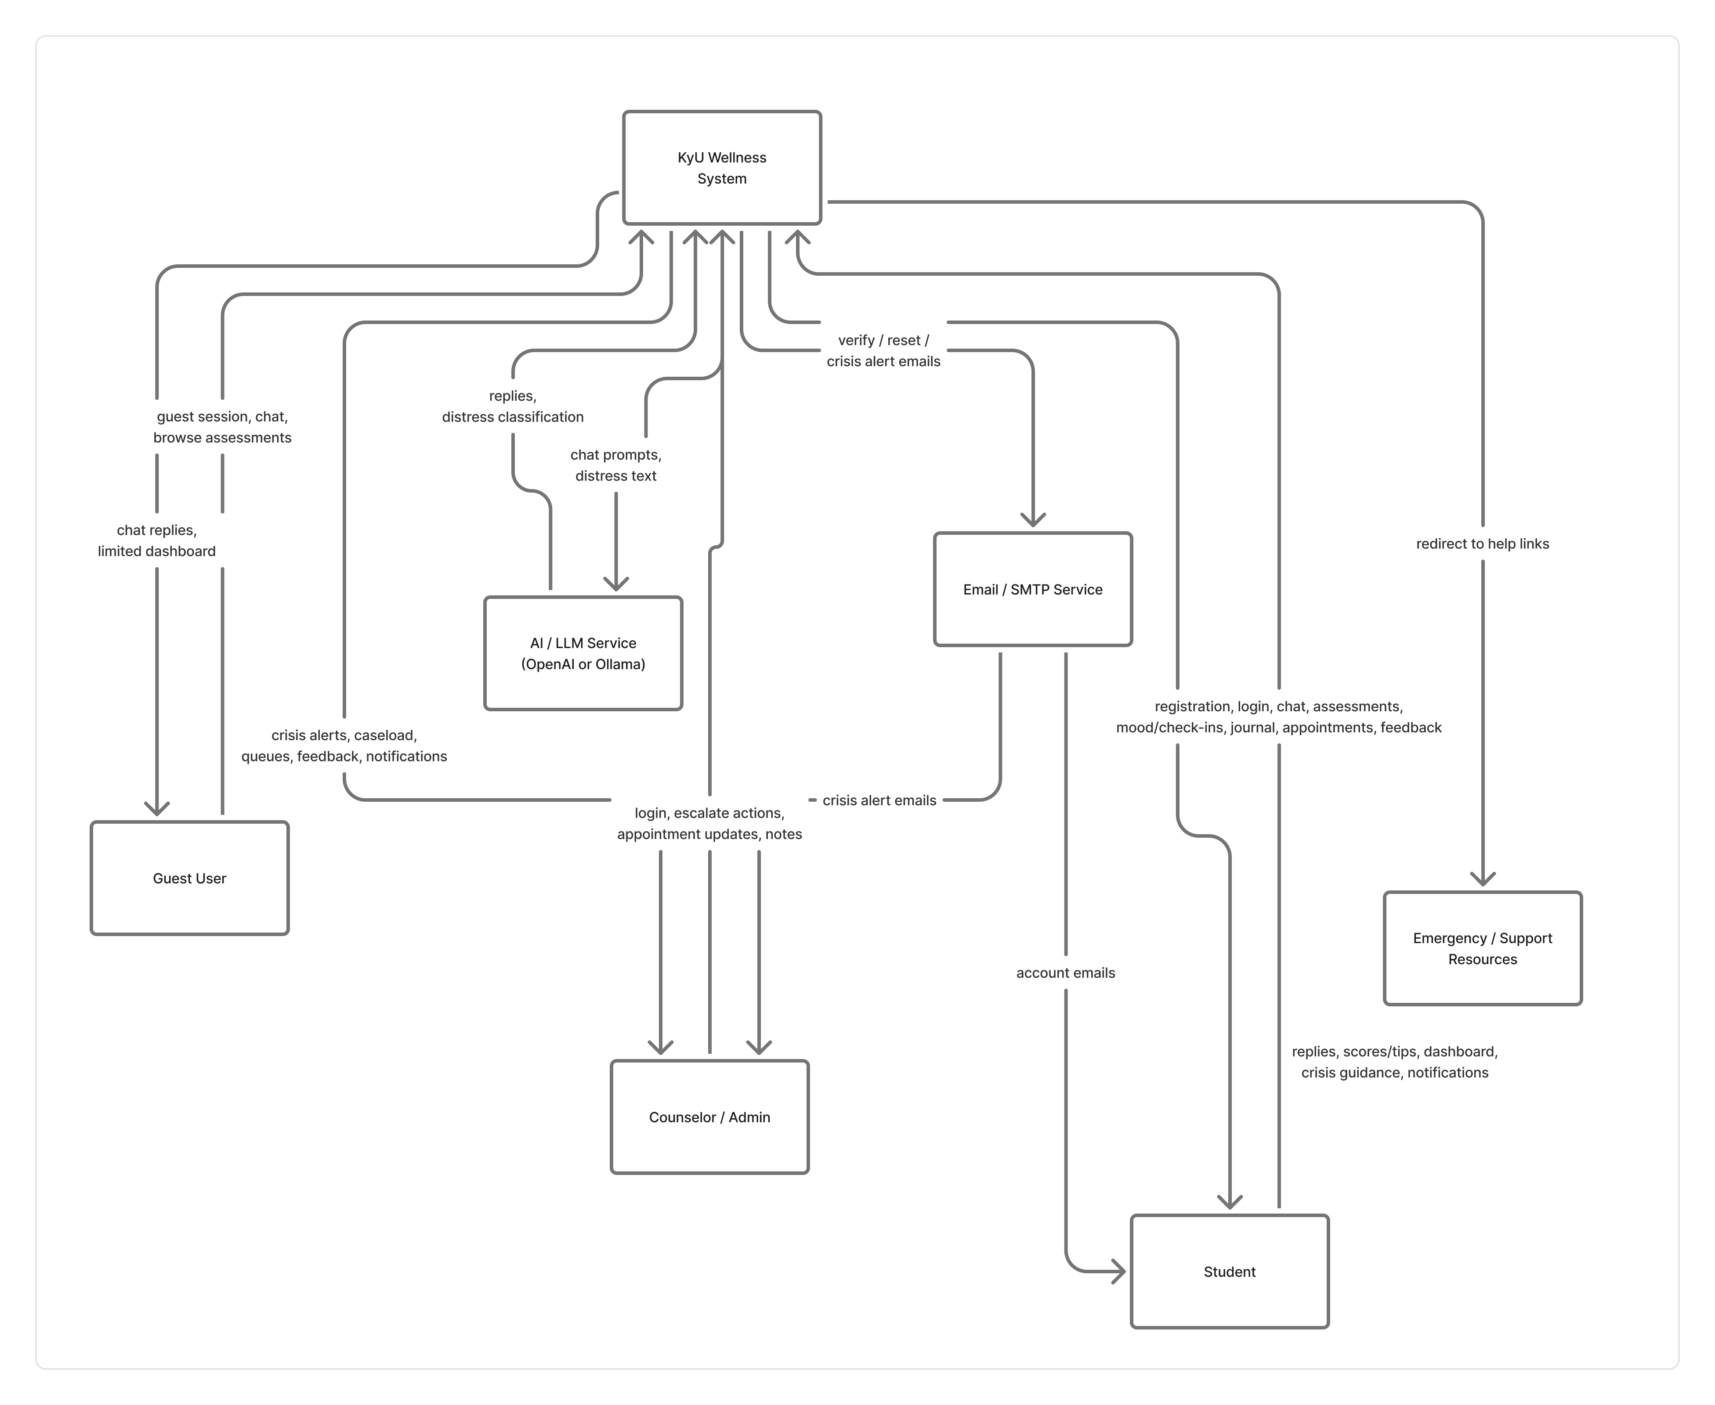
Figure 1: Context diagram for the system.

5.2.2 Level 0 Diagram
The Level 0 diagram decomposes the context diagram into its major functional areas, including user authentication, wellness assessments, AI chat and distress detection, student wellness tracking, counseling operations, and notifications (Kendall & Kendall, 2019; Valacich et al., 2020). Each process shows how data flows between processes, data stores, and external entities (Shelly & Rosenblatt, 2019).
Processes involved:
- Authenticate Users
- Manage Assessments
- Provide AI Chat
- Detect Distress and Escalate
- Track Wellness Data
- Manage Counseling Operations
- Send Notifications and Email
The Level 0 Data Flow Diagram for the AI-Based Mental Health Support System illustrates the interactions between the external entities such as Student, Guest User, Counselor/Administrator, AI/LLM Service, and Email/SMTP Service and the major processes within the system (Kendall & Kendall, 2019).
- Student. Provides registration and login details, assessment responses, chat messages, mood and check-in data, journal entries, appointment requests, and feedback. In return, the student receives authentication confirmation, assessment scores and tips, AI chat replies, wellness dashboard information, crisis guidance when needed, and appointment status updates.
- Guest User. Starts an anonymous session and sends chat messages (and may browse assessment content). The guest receives limited access credentials, AI chat replies, and a restricted dashboard view, without permanent saving of assessments or wellness records.
- Counselor/Administrator. Logs in, reviews and updates crisis escalations, manages appointment statuses, adds counselor notes, and monitors student caseload information. The counselor receives crisis alerts, caseload summaries, appointment queues, feedback lists, in-app notifications, and related operational data from the system.
- AI/LLM Service. Receives chat prompts and message text for distress classification, and returns assistant replies together with distress levels and indicators used by the chat and escalation processes.
- Email/SMTP Service. Receives outbound email payloads from the system and delivers account emails (such as verification and password reset) to students, as well as crisis alert emails to counselors.
In the Level 0 diagram, students and guests interact mainly with authentication, chat, assessment, and wellness processes, while counselors interact with counseling and notification processes. The AI service supports conversational and distress-analysis flows, and the email service supports account communication and crisis alerting, enabling coordinated digital support and timely human follow-up (Shelly & Rosenblatt, 2019; Valacich et al., 2020).
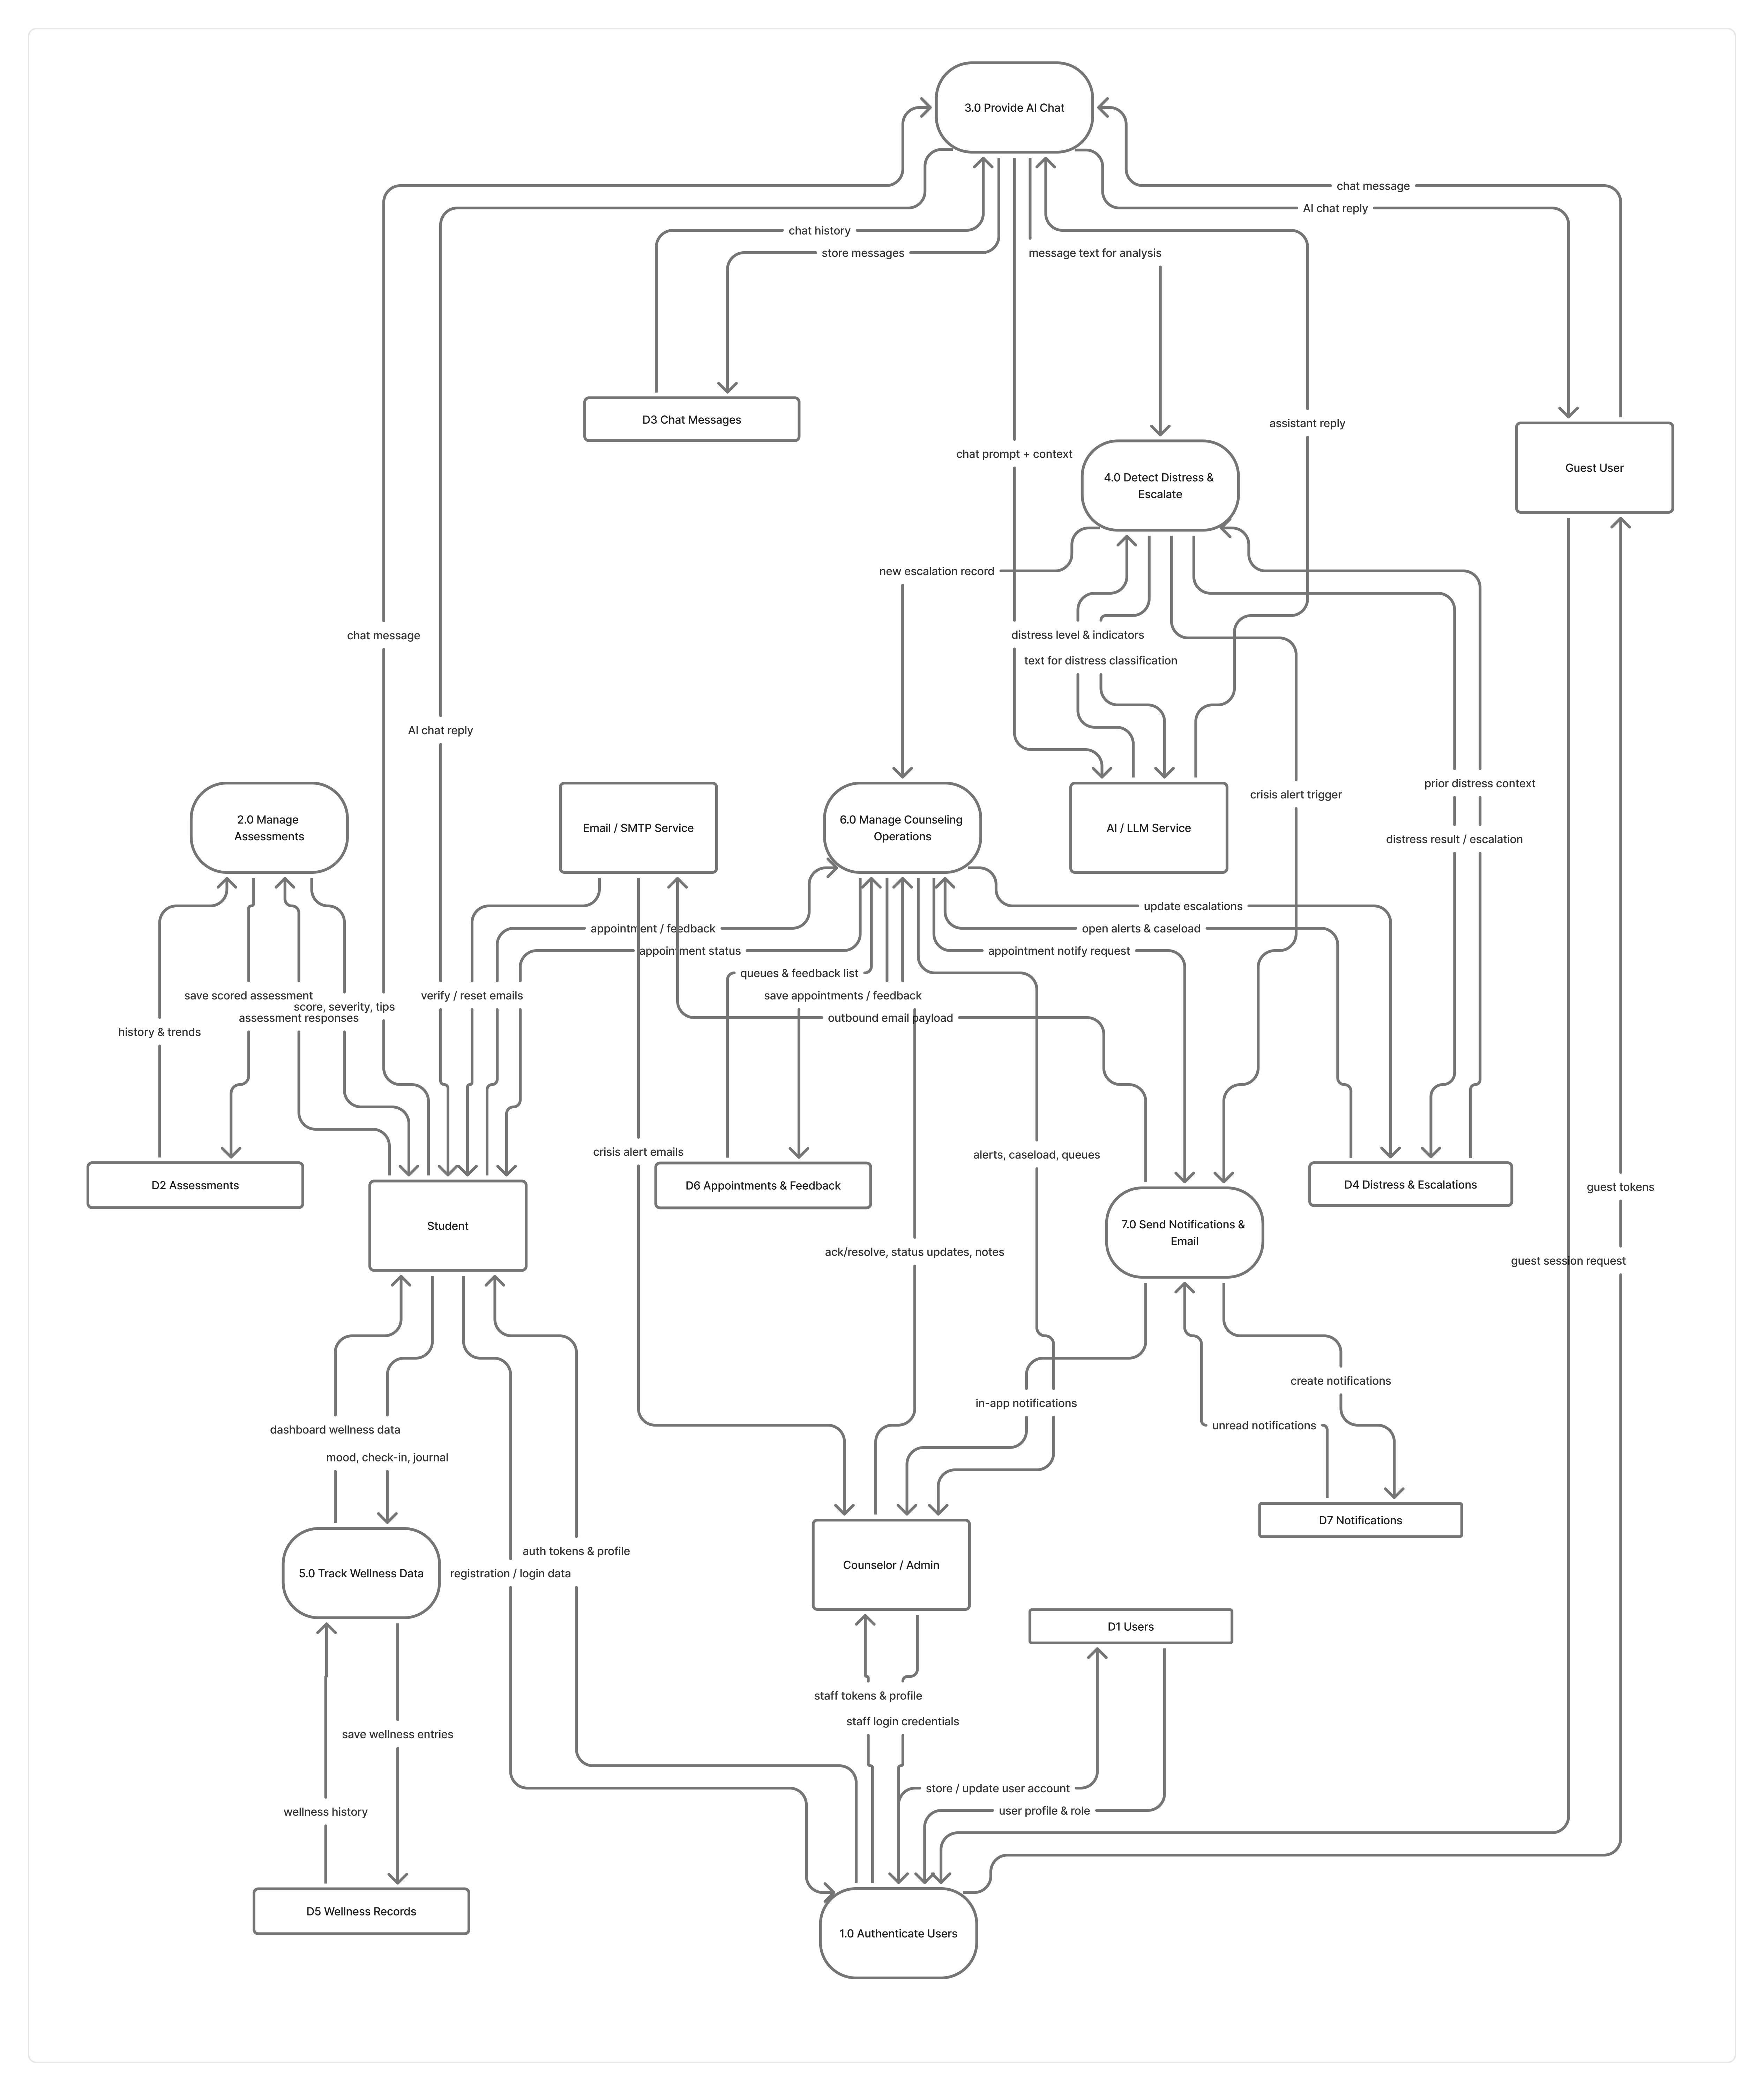
Figure 2: Level 0 data flow diagram for the system.

5.2.3 Level 1 Diagram
The Level 1 diagram further decomposes Process 1.0 (Authenticate Users) providing a more detailed view of the authentication function (Kendall & Kendall, 2019; Valacich et al., 2020). The subprocesses are as below:
1.1 Register Student Account
1.2 Authenticate User Login
1.3 Create Guest Session
1.4 Verify Email Address
1.5 Reset Password
1.6 Manage Session Tokens
This level of detail ensures that the system’s functionality is fully represented and mapped out (Shelly & Rosenblatt, 2019). The diagram below focuses on the process flow related to authenticating users, including data submission, storage, and feedback (Kendall & Kendall, 2019).
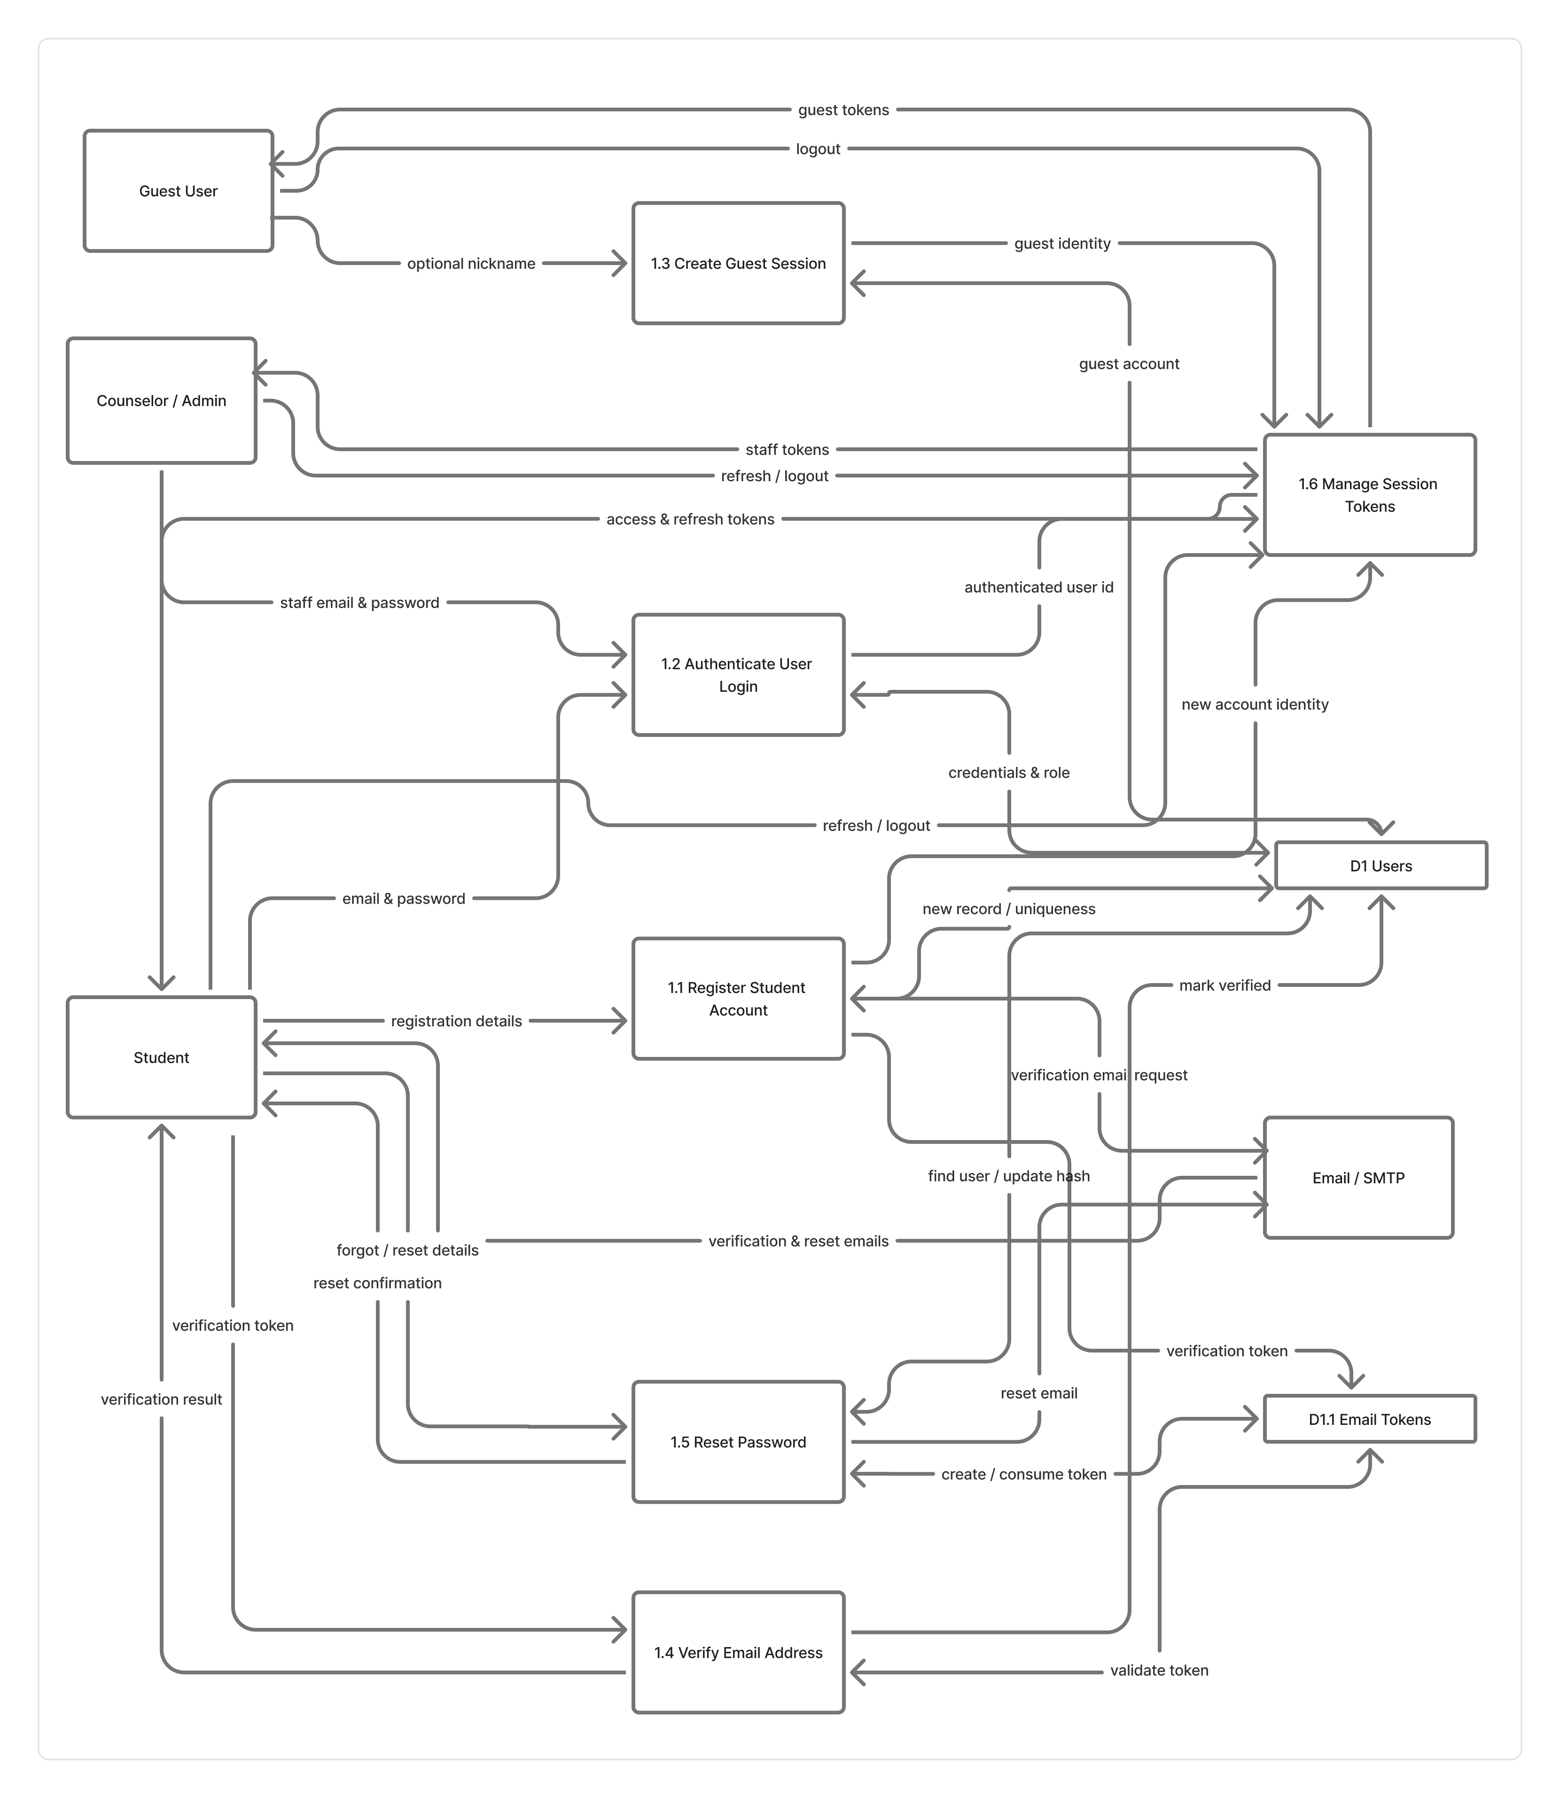
Figure 3: Level 1 data flow diagram of process 1.0 from level 0.

5.3 System Design Using Entity-Relationship Diagrams
An Entity-Relationship Diagram (ERD) shows how data in AI-Based Conversational Mental Health Support System is organised: the main objects stored in the database, their attributes, and how they relate. The design centers on the User entity. Students, guests, counselors, and admins all share this entity and are distinguished by role. Related records cover authentication tokens, assessments, chat, distress detection, escalations, wellness tracking (mood, check-ins, journal), feedback, appointments, and notifications (Valacich et al., 2020; Kendall & Kendall, 2019).

5.3.1 Identified Entities and their Attributes
Table 1: Entities, their descriptions and their attributes.
Entity | Description | Attributes
User | Registered student, guest, counselor, or admin | id (PK), email, password_hash, role, is_anonymous, email_verified, is_active, privacy_consent, age, gender, faculty, year_of_study, nickname, created_at, updated_at
EmailToken | Email verification and password-reset tokens | id (PK), user_id (FK), token, token_type, expires_at, used, created_at
Assessment | PHQ-9, GAD-7, or stress screening results | id (PK), user_id (FK), assessment_type, responses, score, severity, completed_at
ChatSession | A conversation thread with the AI support chat | id (PK), user_id (FK), title, is_active, created_at, updated_at
ChatMessage | Individual message in a chat session | id (PK), session_id (FK), sender, content, metadata, created_at
DistressResult | Distress classification for a user message | id (PK), message_id (FK), level, indicators, rule_matches, ai_analysis, created_at
Escalation | Crisis/high-distress case for counselor follow-up | id (PK), user_id (FK), message_id (FK, optional), level, status, distress_snapshot, counselor_notes, created_at, resolved_at
Notification | In-app alerts (e.g. crisis alerts to counselors) | id (PK), user_id (FK), notification_type, title, body, read, metadata, created_at
MoodEntry | Logged mood score and optional notes | id (PK), user_id (FK), mood_score, mood_label, notes, created_at
DailyCheckin | Daily energy, stress, and sleep check-in | id (PK), user_id (FK), energy_level, stress_level, sleep_quality, notes, created_at
JournalEntry | Private reflective journal text | id (PK), user_id (FK), title, content, created_at, updated_at
Feedback | User rating/comment on the platform | id (PK), user_id (FK), rating, comment, created_at
AppointmentRequest | Request for a counseling appointment | id (PK), user_id (FK), preferred_date, reason, status, created_at

Key relationships
- User has many EmailTokens, Assessments, ChatSessions, MoodEntries, DailyCheckins, JournalEntries, Escalations, Feedback records, AppointmentRequests, and Notifications (One-to-Many).
- ChatSession contains many ChatMessages (One-to-Many).
- ChatMessage produces at most one DistressResult (One-to-One).
- Escalation may reference a ChatMessage (Many-to-One, optional).

5.3.2 Entity Diagram
An ERD, or Entity-Relationship Diagram, is a visual representation of the entities, attributes, relationships, and cardinality within a database system (Kendall & Kendall, 2019). It is a modeling technique used in database design to illustrate the structure and organization of data. Simply put, an ERD is a diagram that shows the entities (objects, concepts, or things) in a database, their attributes (properties or characteristics), and how they are related to each other (Valacich et al., 2020). It provides a clear and concise overview of the database schema, helping database designers, developers, and stakeholders understand the logical structure of the database before implementation (Valacich et al., 2020). By representing entities as rectangles, attributes as ovals, and relationships as lines or connectors, an ERD visually depicts the connections and dependencies between different elements of the database (IBM, 2024). It displays the relationships between entities, the cardinality of those relationships, and the attributes associated with each entity (Atlassian, 2025; Gleek.io, 2025).
The AI-based Conversational Mental Health Support System uses entities such as User, EmailToken, Assessment, ChatSession, ChatMessage, DistressResult, Escalation, Notification, MoodEntry, DailyCheckin, JournalEntry, Feedback, and AppointmentRequest to manage student mental-health support. Users (students, guests, counselors, and admins) interact with the platform through assessments, AI chat sessions, wellness tracking, feedback, and appointment requests. Chat messages may produce distress results, and high-risk cases are recorded as escalations for counselor follow-up, with related notifications delivered in-app. Counselors and administrators oversee alerts, student profiles, and appointment queues to support timely intervention.
This ERD visually represents the relationships and interactions within the system, highlighting how users, chat data, distress detection, and counselor workflows work together to support student well-being, for example, User to ChatSession (one-to-many), ChatSession to ChatMessage (one-to-many), ChatMessage to DistressResult (one-to-one), and User to Escalation (one-to-many) (Kendall & Kendall, 2019; Valacich et al., 2020). The ERD ensures that the system’s database is designed to efficiently store and manage the necessary data.
The figure provides a clear overview of the entity relationships, helping to ensure effective coordination and management of student support data across authentication, chat, assessment, and counselor response (IBM, 2024).

Figure 4: Entity Relationship Diagram of the system.

5.4 Database Design

5.4.1 Database Tables
The database consists of several tables, each corresponding to an entity identified on the ERD. The tables are described as below;
- Users Table.
This represents everyone who uses the AI-Based Conversational Mental Health Support System: students, guests, counselors, and administrators. It stores account identity and access details such as email, password hash, role, verification and consent flags, and optional student profile data (age, gender, faculty, year of study, nickname). Guests may have limited or anonymous data.
Table 2: User Table
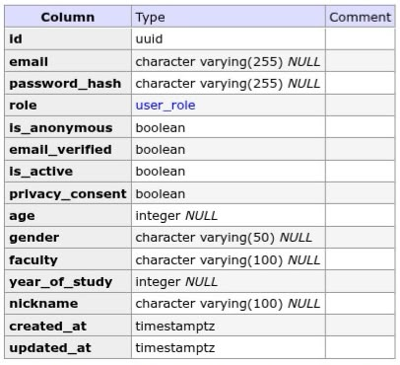
- Email Tokens Table.
This stores one-time security tokens used during account processes. It collects the token value, token type (email verification or password reset), expiry time, whether it has been used, and the linked user.
Table 3: Email Tokens Table
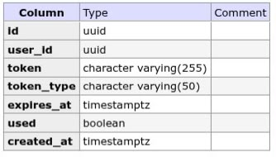
- Assessments Table.
This represents completed mental-health screening records. It collects the assessment type (PHQ-9, GAD-7, or stress), the user’s responses, the computed score, and the resulting severity level.
Table 4: Assessments Table
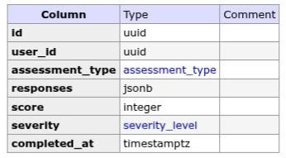
- Chat Sessions Table.
This represents AI support conversations started by a user. It collects session ownership, an optional title, whether the session is active, and timestamps for when the conversation started and was last updated.

Table 5: Chat Sessions Table
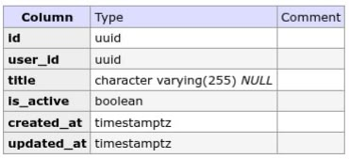
- Chat Messages Table.
This stores individual messages within a chat session. It collects who sent the message (user, assistant, or system), the message content, optional metadata, and the time it was sent.
Table 6: Chat Messages Table
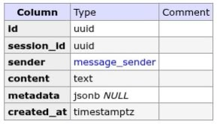
- Distress Results Table.
This represents the distress analysis produced for a user message. It collects the distress level (low, moderate, high, or crisis), detected indicators, rule-based matches, and AI analysis details used to decide whether escalation is needed.
Table 7: Distress Results Table
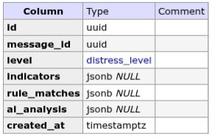
- Escalations Table.
This represents high-risk or crisis cases that require counselor follow-up. It collects the affected student, optional triggering message, distress level, case status, a snapshot of distress details, counselor notes, and resolution time.
Table 8: Escalations Table
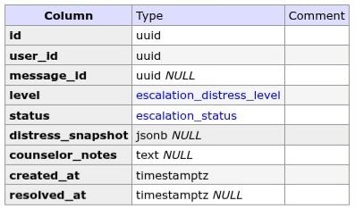
- Notifications Table.
This stores in-app alerts sent to users, especially counselors and admins. It collects notification type, title, body, read status, optional linked metadata, and the time the alert was created.

Table 9: Notifications Table
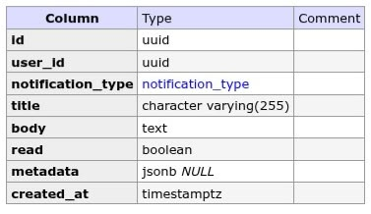
- Mood Entries Table.
This represents mood logs submitted by students. It collects a mood score, an optional mood label, optional notes, and the time the mood was recorded.
Table 10: Mood Entries Table
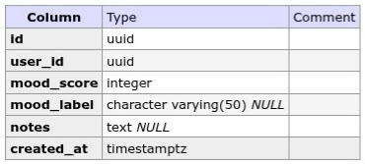
- Daily Check-ins Table.
This stores routine daily wellness check-ins. It collects energy level, stress level, optional sleep quality, optional notes, and the check-in timestamp.

Table 11: Daily Check-ins Table
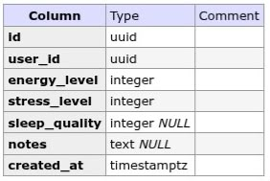
- Journal Entries Table.
This represents private reflective writing by students. It collects an optional title, journal content, and timestamps for creation and last update.
Table 12: Journal Entries Table
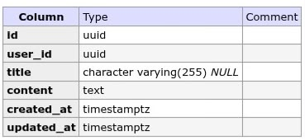
- Feedback Table.
This stores user opinions about the platform. It collects an optional rating, optional written comment, and the time feedback was submitted.
Table 13: Feedback Table
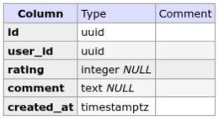
- Appointment Requests Table.
This represents student requests for counseling appointments. It collects preferred date/time, reason for the request, current status (for example pending), and the time the request was made.
Table 14: Appointment Requests Table
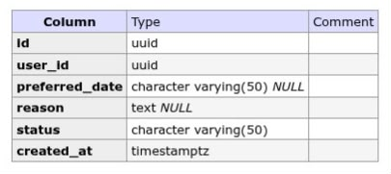

5.4.2 Data Descriptions
Below is the description of the data contained in the tables in the database;
- Users Table
The User entity represents everyone who uses the AI-Based Conversational Mental Health Support System, including students, guests, counselors, and administrators. Role determines the level of access: students and guests use support features, while counselors and admins manage alerts, caseloads, and system oversight.
Attributes
id: A unique identifier for each user.
email: The login email address of the user (nullable for guests).
password_hash: The securely hashed password used for authentication (nullable for guests).
role: The user’s role in the system (student, guest, counselor, or admin).
is_anonymous: Indicates whether the account is an anonymous guest session.
email_verified: Indicates whether the user’s email has been verified.
is_active: Indicates whether the account is active.
privacy_consent: Indicates whether the user accepted privacy terms.
age: The age of the user.
gender: The gender of the user.
faculty: The faculty or school of the student.
year_of_study: The student’s year of study.
nickname: An optional display name for the user.
created_at: The date and time when the account was created.
updated_at: The date and time when the account was last updated.
- Email Tokens Table
The EmailToken entity represents one-time security tokens used for email verification and password reset. It supports account confirmation and secure recovery of login credentials.
Attributes
id: A unique identifier for each token record.
user_id: The identifier of the user who owns the token.
token: The unique secure token string.
token_type: The purpose of the token (email verification or password reset).
expires_at: The date and time when the token expires.
used: Indicates whether the token has already been used.
created_at: The date and time when the token was created.
- Assessments Table
The Assessment entity represents completed mental-health screening records such as PHQ-9, GAD-7, and PSS-10 assessments. It stores responses and results used to understand a student’s well-being level.
Attributes
id: A unique identifier for each assessment.
user_id: The identifier of the user who completed the assessment.
assessment_type: The type of assessment (phq9, gad7, or pss10).
responses: The answers submitted by the user.
score: The computed total score for the assessment.
severity: The severity level derived from the score (low, moderate, or high).
completed_at: The date and time when the assessment was completed.
- Chat Sessions Table
The ChatSession entity represents an AI support conversation between a user and the system. Each session groups related messages into one continuous chat thread.
Attributes
id: A unique identifier for each chat session.
user_id: The identifier of the user who owns the session.
title: An optional title for the conversation.
is_active: Indicates whether the session is still active.
created_at: The date and time when the session was created.
updated_at: The date and time when the session was last updated.
- Chat Messages Table
The ChatMessage entity represents individual messages exchanged within a chat session. It stores what was said, who said it, and when it was sent.
Attributes
id: A unique identifier for each message.
session_id: The identifier of the chat session the message belongs to.
sender: The sender of the message (user, assistant, or system).
content: The text content of the message.
metadata: Optional additional information about the message.
created_at: The date and time when the message was sent.
- Distress Results Table
The DistressResult entity represents the distress analysis produced for a user chat message. It records how severe the message appears and what evidence supported that classification.
Attributes
id: A unique identifier for each distress result.
message_id: The identifier of the chat message that was analyzed.
level: The distress level (low, moderate, high, or crisis).
indicators: Detected distress indicators from the message.
rule_matches: Rule-based pattern matches found in the message.
ai_analysis: AI classification details for the message.
created_at: The date and time when the result was generated.
- Escalations Table
The Escalation entity represents high-risk or crisis cases that require counselor attention. It links a student (and optionally a triggering message) to a follow-up case for counseling staff.
Attributes
id: A unique identifier for each escalation.
user_id: The identifier of the student requiring follow-up.
message_id: The optional identifier of the message that triggered the escalation.
level: The distress level that caused the escalation.
status: The current case status (open, acknowledged, or resolved).
distress_snapshot: A snapshot of distress details at the time of escalation.
counselor_notes: Notes added by a counselor about the case.
created_at: The date and time when the escalation was created.
resolved_at: The date and time when the escalation was resolved.
- Notifications Table
The Notification entity represents in-app alerts delivered to users, especially crisis alerts for counselors and administrators. It helps staff respond quickly to urgent student cases.
Attributes
id: A unique identifier for each notification.
user_id: The identifier of the recipient user.
notification_type: The type of notification (crisis_alert, system, or reminder).
title: The title of the notification.
body: The full notification message.
read: Indicates whether the notification has been read.
metadata: Optional linked data, such as an escalation reference.
created_at: The date and time when the notification was created.
- Mood Entries Table
The MoodEntry entity represents mood logs submitted by students. It supports self-tracking of emotional state over time.
Attributes
id: A unique identifier for each mood entry.
user_id: The identifier of the user who logged the mood.
mood_score: The numeric mood score recorded by the user.
mood_label: An optional label describing the mood.
notes: Optional notes related to the mood entry.
created_at: The date and time when the mood was logged.
- Daily Check-ins Table
The DailyCheckin entity represents routine daily wellness check-ins. Students record energy, stress, and sleep information to track day-to-day well-being.
Attributes
id: A unique identifier for each check-in.
user_id: The identifier of the user who submitted the check-in.
energy_level: The self-rated energy level for the day.
stress_level: The self-rated stress level for the day.
sleep_quality: The optional self-rated sleep quality.
notes: Optional notes about the day’s well-being.
created_at: The date and time when the check-in was submitted.
- Journal Entries Table
The JournalEntry entity represents private reflective writing by students. It allows users to record thoughts and feelings in a personal journal.
Attributes
id: A unique identifier for each journal entry.
user_id: The identifier of the user who wrote the entry.
title: An optional title for the journal entry.
content: The main text of the journal entry.
created_at: The date and time when the entry was created.
updated_at: The date and time when the entry was last updated.
- Feedback Table
The Feedback entity represents user opinions about the platform. It stores ratings and comments that help improve the AI-Based Conversational Mental Health Support System.
Attributes
id: A unique identifier for each feedback record.
user_id: The identifier of the user who submitted the feedback.
rating: An optional numeric rating of the platform.
comment: An optional written comment from the user.
created_at: The date and time when the feedback was submitted.
- Appointment Requests Table
The AppointmentRequest entity represents student requests for counseling appointments. It helps counselors manage booking interest and follow up with students who need in-person or scheduled support.
Attributes
id: A unique identifier for each appointment request.
user_id: The identifier of the student making the request.
preferred_date: The preferred date or time for the appointment.
reason: The reason for requesting counseling support.
status: The current status of the request.
created_at: The date and time when the request was created.

5.5 System Implementation
The implementation of the AI-Based Mental Health Support System involved various stages and was critical in transforming the system design into a functional system that meets the requirements specified in earlier stages. Below is a detailed explanation of how the system was implemented, the tools used in its development, and screenshots of the system’s main interfaces.

5.5.1 Implementation Process
The AI-Based Conversational Mental Health Support System was implemented in stages, moving from foundation setup to full feature delivery, testing, and deployment preparation. The process used was incremental and modular, so each major function was built, tested, and integrated before moving to the next. The following are the implementation processes;
1. Requirements analysis and system design
The project began by identifying the needs of Kyambogo University students and counselors. Requirements such as authentication, assessments, AI chat, distress detection, crisis escalation, wellness tracking, and counselor monitoring were defined. These requirements guided the database design, process models (DFDs), ERD, and system architecture.
2. Environment and foundation setup
The development environment was set up with React/Vite for the frontend, FastAPI for the backend, and PostgreSQL for data storage. Docker Compose was configured to run the database, API, and Mailhog email service. Project structure, configuration files, database connection, and a health-check endpoint were created first to confirm that the platform foundation was working.
3. Database implementation
Database tables were created from the ERD using SQLAlchemy models and Alembic migrations. Core tables such as users, assessments, chat_sessions, chat_messages, distress_results, escalations, and related wellness tables were implemented to support system data storage and relationships.
4. Core module development
The system was built module by module in this order:
- Authentication and user management (register, login, guest access, email verification, password reset, roles)
- Mental-health assessments (PHQ-9, GAD-7, PSS-10 scoring and history)
- Distress detection (rule-based analysis and hybrid AI classification)
- AI chatbot (session creation, messaging, CBT-informed responses)
- Crisis escalation and notifications (counselor alerts and case tracking)
- Student wellness features (dashboard, mood logs, daily check-ins, journal)
- Counselor/admin tools (dashboard, student caseload, escalations, appointments, feedback)
- Support pages and localization (About, Resources, Emergency, Privacy)
5. Frontend and backend integration
Each backend API was connected to corresponding frontend pages. Role-based navigation was implemented so students, guests, and counselors access different interfaces. Forms, dashboards, chat screens, and counselor tools were linked to live API endpoints and database records.
6. Testing and refinement
Unit tests were written for key backend logic such as scoring, security, and distress detection. Integration and system testing were done using Docker, Swagger, and manual browser testing. Issues found during testing were fixed and retested.

5.5.2 Development Tools and Technologies
The following tools and technologies were used in the design and development of the system:
1. Programming Languages
Python: Used for backend logic, API development, business rules, and database interactions.
TypeScript / JavaScript: Used for building the frontend application and interactive user interfaces.
HTML and CSS: Used for structuring and styling the web pages and user interface components.
SQL: Used for defining, querying, and managing data in the PostgreSQL database.
2. Frameworks and Libraries
FastAPI: Used as the backend web framework for creating REST API endpoints.
React and Vite: Used to build the frontend single-page application.
SQLAlchemy and Alembic: Used for database modeling and migrations.
Tailwind CSS and Framer Motion: Used for UI styling and interface animations.
React Router: Used for page navigation and English language support.
3. Database Management System
PostgreSQL: Used to store and retrieve system data such as users, assessments, chat messages, distress results, escalations, notifications, journal entries, feedback, and appointment requests.
4. Artificial Intelligence and Communication Tools
Ollama: Used to generate AI chat responses and support distress analysis.
Mailhog: Used for sending email verification, password reset, and crisis alert emails during development.
5. Development and Deployment Tools
Docker and Docker Compose: Used to run PostgreSQL, the backend API, and Mailhog in a local development environment.
pytest: Used for automated backend unit and service testing.
Swagger: Used to document and test API endpoints.
Git: Used for version control during system development.
6. Platform: The system was implemented as a web-based application and developed on a Linux environment. It runs through a browser-based frontend connected to a FastAPI backend and PostgreSQL database.

5.5.3 System Graphical User Interfaces
Home page
Shows the public entry point, language toggle (EN/LG), and main features (chat, assessments, crisis support).
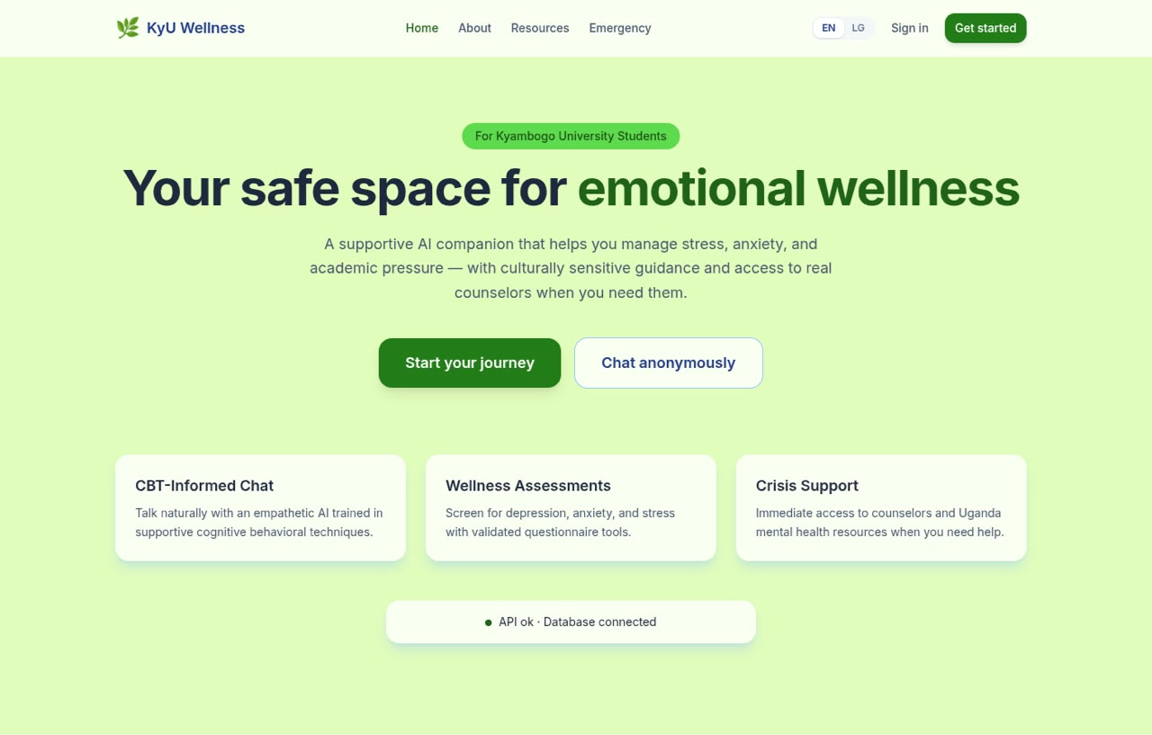
Figure 5: Home / landing page
Login page
Shows authentication options: email/password sign-in, registration, password reset, and guest access.
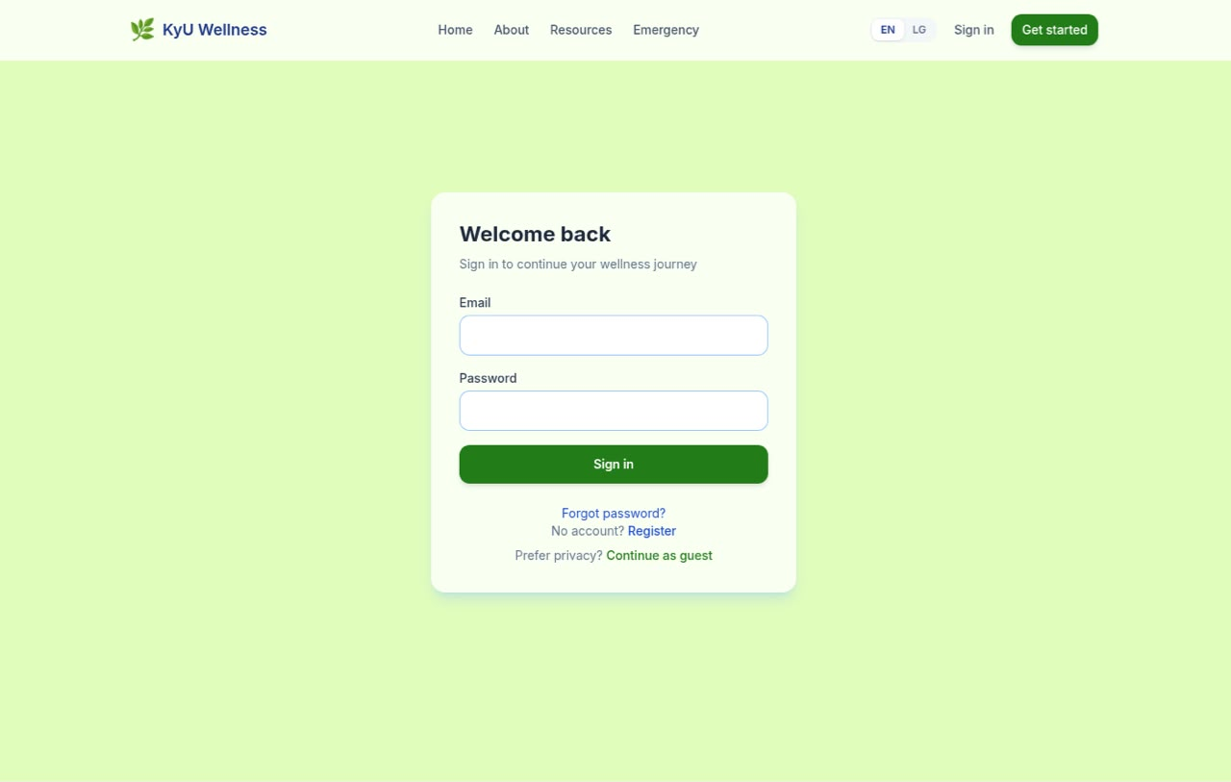
Figure 6: Login page with blank input fields
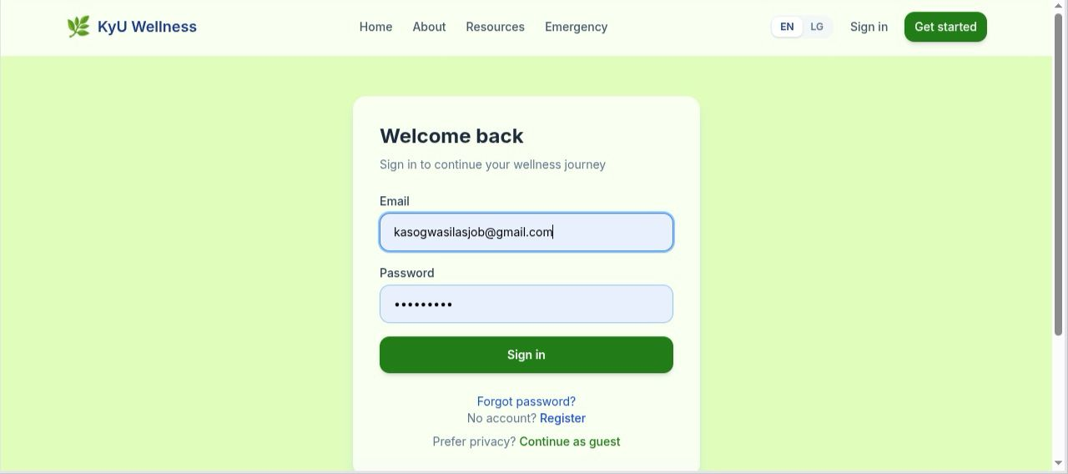
Figure 7: Login page with filled input fields
Student dashboard
Shows mood logging, daily check-in, activity summary, and navigation to chat, assessments, journal, appointments, and feedback.
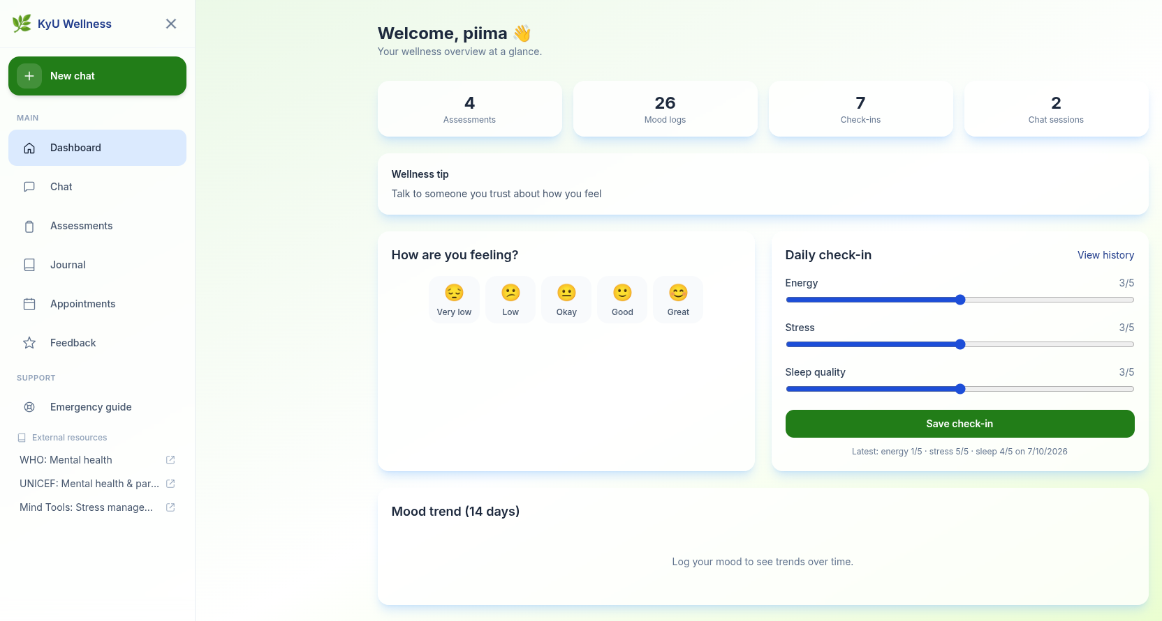
Figure 8: Student wellness dashboard
AI chat interface
Shows CBT-informed chat sessions, message exchange, and crisis alert behaviour when high-risk content is detected.
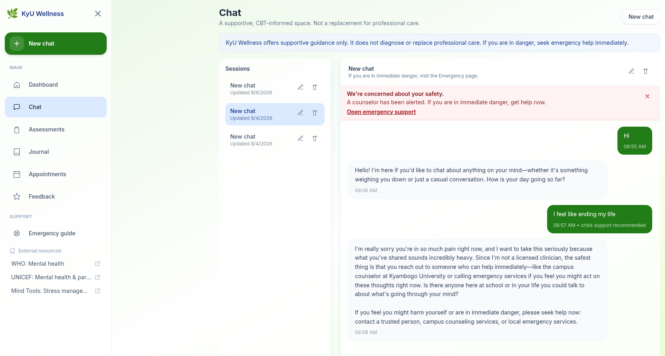
Figure 9: AI chat interface
Counselor dashboard
Shows counselor overview of students, escalations, distress trends, assessment severity, and recent crisis alerts.
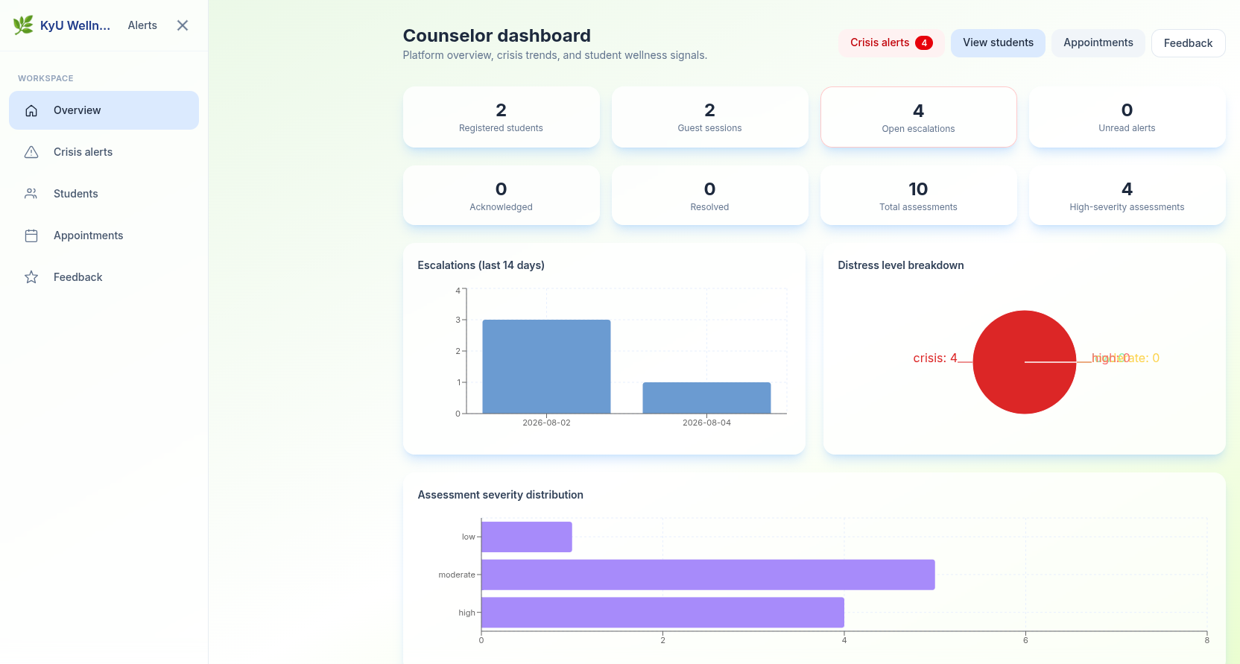
Figure 10: Counselor dashboard
These screenshots demonstrate that the implemented system covers student access, AI support, screening tools, and counselor monitoring as designed.

5.5.4 Sample Code
import { Link, NavLink, Outlet, useLocation } from 'react-router-dom';
import { useEffect, useState } from 'react';
import { motion, AnimatePresence } from 'framer-motion';
import { useTranslation } from 'react-i18next';
import { useAuth } from '../context/AuthContext';
import LanguageSwitcher from '../components/LanguageSwitcher';

function MenuIcon({ open }: { open: boolean }) {
const base =
'absolute left-1/2 top-1/2 block h-0.5 w-[18px] rounded-full bg-current ' +
'transition-transform duration-300 ease-[cubic-bezier(0.4,0,0.2,1)]';
return (
<span className="relative block h-5 w-5" aria-hidden="true">
<span
className={base}
style={{
transform: open
? 'translate(-50%, -50%) rotate(45deg)'
: 'translate(-50%, -50%) translateY(-6px)',
}}
/>
<span
className={`${base} transition-[transform,opacity] duration-200`}
style={{ transform: 'translate(-50%, -50%)', opacity: open ? 0 : 1 }}
/>
<span
className={base}
style={{
transform: open
? 'translate(-50%, -50%) rotate(-45deg)'
: 'translate(-50%, -50%) translateY(6px)',
}}
/>
</span>
);
}

export default function MainLayout() {
const { isAuthenticated } = useAuth();
const { t } = useTranslation();
const location = useLocation();
const [menuOpen, setMenuOpen] = useState(false);

const navLinks = [
{ to: '/', label: t('common.home'), end: true },
{ to: '/about', label: t('common.about') },
{ to: '/resources', label: t('common.resources') },
{ to: '/emergency', label: t('common.emergency') },
{ to: '/privacy', label: t('common.privacy') },
];

5.6 System Testing and Validation

5.6.1 System Testing
The system underwent testing at various levels as shown below;
Unit Testing
Unit testing was used to verify that individual components of the AI-based Conversational Mental Health Support System work correctly in isolation. In this project, unit tests were mainly written for the backend using pytest. These tests focused on small pieces of logic such as password hashing, token generation and validation, assessment scoring, distress classification, wellness calculations, and schema validation. For example, tests checked that PHQ-9, GAD-7, and PSS-10 assessments produce the correct score and severity, that crisis statements are classified at the correct distress level, and that invalid inputs are rejected. Unit testing helped detect errors early and ensured that core business logic behaved as expected before integrating it with other modules.
Integration Testing
Integration testing was used to confirm that different modules of the system work correctly together as a complete application. In the AI-based Conversational Mental Health Support System, this involved testing how the frontend, backend, database, AI services, email service, and authentication flow interact. The system was run in a local Docker environment with PostgreSQL, FastAPI, and Mailhog, and the API endpoints were exercised through Swagger and manual requests. Integration testing verified workflows such as user registration storing data in the database, login issuing tokens, assessments being submitted and saved, chat messages producing distress results, and crisis escalations creating notifications for counselors. This type of testing ensured that connected parts of the system exchanged data properly and supported the required end-to-end behaviour.
System Testing
System testing was carried out to evaluate the AI-based Conversational Mental Health Support System as a complete and integrated system. System testing examined whether all modules of the application worked together correctly in the actual operating environment. The aim was to verify that the system met its functional requirements and performed as expected from end to end.
In this project, system testing involved running the full platform with its main components: the React frontend, FastAPI backend, PostgreSQL database, email service, and AI chat integration. The system was tested in a local environment using Docker Compose so that interactions between services could be observed under realistic conditions.
System testing also checked whether data was correctly stored and retrieved from the database, whether APIs returned expected responses, and whether user roles controlled access properly. For example, students could only access their own records, while counselors and administrators could access support and monitoring functions relevant to their responsibilities.
The results of system testing showed that the AI-based Conversational Mental Health Support System operated correctly as an integrated platform. Core workflows such as assessment submission, AI-supported conversation, escalation of high-risk cases, and counselor follow-up were all successfully executed. This confirmed that the system was functioning as intended within the scope of the project.
User Acceptance Testing (UAT)
User acceptance testing was used to determine whether the AI-based Conversational Mental Health Support System meets the actual needs of its intended users. This testing focused on realistic user tasks and overall usability rather than internal code behaviour. For the student side, acceptance testing involved checking whether a student could register, log in, complete assessments, chat with the AI assistant, record mood and daily check-ins, write journal entries, submit feedback, and request appointments without difficulty. For the counselor side, it involved confirming that counselors could log in, view alerts, access student details, manage escalations, and handle appointment requests. UAT helped confirm that the system was understandable, functional, and appropriate for supporting student mental health in the university context.

5.6.2 System Validation
Validation focused on ensuring that the system fulfilled all user requirements for students, guests, counselors, and administrators. Pilot testing was conducted in a controlled Kyambogo University development environment, using student and counselor accounts, to validate the system under realistic use. The validation process involved checking the implemented system against the specified requirements and confirming that user inputs matched the expected formats and workflows. Several validation checks, including data and security validation, were carried out to ensure that the system accepted valid input, rejected data supplied in the wrong format, and prevented unauthorized users from accessing protected system resources.

5.7 Chapter Summary
This chapter presented the design, implementation, testing, and validation of the proposed AI-Based Conversational Mental Health Support System. It described the system design using Data Flow Diagrams (DFDs), Entity-Relationship Diagrams (ERDs), and database design to illustrate the system architecture, data flow, and data storage structures. The chapter also explained the development tools and technologies used to implement the system, including the frontend, backend, database, and AI components. Finally, it discussed the system testing process through unit, integration, system, and user acceptance testing, demonstrating that the system functions correctly, meets the specified requirements, and is capable of providing secure, reliable, and effective mental health support for university students.

CHAPTER 6: DISCUSSION, RECOMMENDATIONS, AND CONCLUSION

6.1 Introduction
This chapter presents the discussion of the findings from the design, implementation, and testing of the AI-Based Conversational Mental Health Support System. It also provides recommendations for improving the system, outlines the limitations of the study, suggests areas for further research, and concludes the project. The chapter reflects on how well the system met its objectives of supporting Kyambogo University students through AI-assisted mental health guidance, assessments, wellness tracking, and counselor escalation.

6.2 Discussion
The study set out to design and implement a web-based platform that provides accessible mental health support for university students. The completed system demonstrates that digital tools can complement existing counseling services by offering continuous, confidential, and culturally sensitive support.
The authentication module successfully supports registered students, anonymous guests, counselors, and administrators. This is important because some students may prefer privacy when seeking help. Guest access lowers the barrier to entry, while registered accounts enable long-term tracking of assessments, mood, check-ins, and journal entries.
The assessment module provides validated screening tools (PHQ-9, GAD-7, and PSS-10). These tools help students reflect on depression, anxiety, and stress levels and give counselors useful signals for follow-up. The system does not diagnose conditions; instead, it functions as an early screening and awareness tool, which is appropriate for a university support setting.
The AI chat module provides CBT-informed conversational support. Combined with hybrid distress detection (rule-based patterns and AI analysis), the system can identify concerning language and escalate high-risk cases to counselors. This is one of the most important contributions of the project, because it links immediate digital support with human intervention when crisis indicators appear.
The counselor dashboard strengthens the link between student activity and professional response. Counselors can view escalations, student summaries, appointments, and feedback. This improves coordination and reduces the chance that high-risk messages go unnoticed.
Overall, testing and validation confirmed that the system’s major workflows operate as intended: registration and login, assessment scoring, chat and distress analysis, crisis escalation, wellness tracking, and counselor monitoring. The results suggest that AI-Based Conversational Mental Health Support System can serve as a practical support layer within the university mental health ecosystem, provided it is used alongside professional counseling rather than as a replacement for it.

6.3 Recommendations
To further improve the effectiveness of the system, the following recommendations are made for future iteration or upgrade of the system;
- Institutional adoption and training. Kyambogo University counseling services should be trained to use the counselor dashboard so escalations and appointment requests are handled promptly.
- Stronger privacy and data governance. Clear data retention, consent, and access-control policies should be enforced, especially for sensitive chat and assessment data.
- Improved crisis response protocols. Escalation alerts should be linked to defined counselor response times and on-call procedures to ensure timely human follow-up.
- Broader awareness among students. The university should promote the platform through orientation, faculty channels, and student welfare offices so more students can access support early.
- Continuous model and content review. AI prompts, distress rules, and emergency resources should be reviewed regularly with counselors to keep guidance accurate and culturally appropriate.
- Mobile-first accessibility. Further improvement of mobile usability is recommended so students can access support conveniently on smartphones.
- University computer access. The system should be deployed on shared university computers in libraries and labs, using kiosk mode and guest sessions to enable private access for students without personal devices.
- Multilingual support. Multilingual support should be added so students can use the system in their preferred local language, improving inclusivity and cultural relevance.

6.4 Limitations of the Study
Despite achieving the project objectives, several limitations were identified:
- Not a clinical diagnostic system. The platform provides screening and supportive guidance only. It cannot replace professional diagnosis or therapy.
- Dependence on AI quality. Chat responses depend on the configured LLM. Response quality and speed may vary with model choice and infrastructure.
- Limited real-world pilot scope. Testing was mainly conducted in a controlled development environment. Large-scale student and counselor pilot studies were not fully carried out within the project period.
- Internet and infrastructure dependence. The system requires reliable internet and server availability. Students with limited connectivity may face access challenges.
- Manual counselor capacity. Escalation effectiveness depends on counselors being available to respond. Technology alone cannot guarantee immediate human intervention.

6.5 Area for Further Research
Future research and development may focus on the following areas:
- Large-scale user evaluation. Conduct formal usability and outcome studies with Kyambogo students and counselors to measure impact on help-seeking behaviour and well-being.
- Advanced risk prediction. Explore machine-learning models that combine chat distress signals, assessment trends, mood logs, and check-ins for earlier risk prediction.
- Integration with university counseling systems. Integrate appointment booking, counselor calendars, and case management more deeply with existing university welfare systems.
- Mobile application development. Develop native Android/iOS apps for improved accessibility and push notifications for crisis alerts.
- Expanded local language support. Introduce Luganda conversational support and culturally adapted mental health content for broader student reach.
- Secure cloud migration and analytics. Deploy on managed cloud infrastructure with privacy-preserving analytics dashboards for institutional decision-making.

6.6 Conclusion
This project successfully designed, implemented, and tested an AI-Based Conversational Mental Health Support System for Kyambogo University students. The system provides authentication, validated assessments, CBT-informed AI chat, hybrid distress detection, crisis escalation, wellness tracking, and counselor monitoring tools.
The study demonstrates that digital mental health support can improve access to help, encourage early self-assessment, and connect high-risk cases to human counselors. While the system has limitations and is not a substitute for professional care, it offers a practical and scalable foundation for university-based mental health support.
In conclusion, the AI-Based Conversational Mental Health Support System meets its core objectives and contributes a useful technological approach to student well-being support. With institutional adoption, continuous improvement, and further research, the system can play an important role in strengthening mental health services at Kyambogo University.

REFERENCES
Aceng, J.R. (2026) 'State of Population Report 2026 Launch'. Uganda Media Centre, 18 February. Available at: https://youtu.be/7KRNd2UeJhw?si=cRG7y9VYTul-zy47
Ali, M., Ali, S., Abbas, Q., Abbas, Z., & Lee, S. W. (2025). Artificial intelligence for mental health: A narrative review of applications, challenges, and future directions in digital health. DIGITAL HEALTH. Available at: https://doi.org/10.1177/20552076251395548
Amropali Shetty. (2025). What is conversational AI? – Benefits and Examples. yellow.ai. Available at: https://yellow.ai/conversational-ai/
Andualem, F., Melkam, M., Takelle, G. M., Nakie, G., Tinsae, T., Fentahun, S., Rtbey, G., Begashaw, T. D., Seid, J., Tegegn, L. F., Gedef, G. M., Bitew, D. A., & Godana, T. N. (2024). Prevalence of posttraumatic stress disorder and associated factors among displaced people in Africa: a systematic review and meta-analysis. Frontiers in Psychiatry, 15, 1336665. https://doi.org/10.3389/fpsyt.2024.1336665
Atlassian. (2025). What is an ERD? Entity relationship diagram. Available at: https://www.atlassian.com/work-management/project-management/entity-relationship-diagram
Belz, F.F., Vega Potler, N.J., Johnson, I.N. et al. (2024). Lessons From Low‐ and Middle‐Income Countries: Alleviating the Behavioral Health Workforce Shortage in the United States. Psychiatric Services, 75, 699–702. https://psychiatryonline.org/doi/abs/10.1176/appi.ps.20230348
Berrezueta-Guzman, S., Kandil, M., Martín-Ruiz, M.-L., Pau de la Cruz, I., & Krusche, S. (2024). Future of ADHD Care: Evaluating the Efficacy of ChatGPT in Therapy Enhancement. Healthcare, 12(6), 683. https://doi.org/10.3390/healthcare12060683
Bhagia, Y., Abbas, S.M., Kumar, S. and Maheshwari, S. (2024). Conversational AI: A survey. International Research Journal of Engineering and Technology (IRJET), 11(4), pp.833–842. Available at: https://www.irjet.net/archives/V11/i4/IRJET-V11I4139.pdf
B.J. Copeland. (2026). Artificial Intelligence. Britannica. Available at: https://www.britannica.com/technology/artificial-intelligence/Reasoning
Cockburn, A. (2000). Writing effective use cases. Boston, MA: Addison-Wesley Professional.
Cohen, S., Kamarck, T. and Mermelstein, R. (1983). A global measure of perceived stress. Journal of Health and Social Behavior, 24(4), pp.385–396.
Cohen, S. and Williamson, G. (1988). Perceived stress in a probability sample of the United States. In: Spacapan, S. and Oskamp, S. (eds.) The Social Psychology of Health: Claremont Symposium on Applied Social Psychology. Newbury Park, CA: Sage, pp.31–67.
Damelio, R. (2011). The Basics of Process Mapping. 2nd edn. Productivity Press. doi:10.4324/9781439891278.
Dean of Students Office, Guidance and Counselling Unit. Kyambogo University. Available at: https://welfare.kyu.ac.ug/dean-of-students-office/guidance-and-counselling-unit/
European Union. (2024). Regulation (EU) 2024/1689 (Artificial Intelligence Act), Article 3(1).
Galatzer-Levy, I.R., McDuff, D., Natarajan, V. et al. (2023). The capability of large language models to measure psychiatric functioning. arXiv, 2308.01834.
Gleek.io. (2025). All about ER model cardinality with examples. Available at: https://www.gleek.io/blog/er-model-cardinality
Grabb, D. (2023). The impact of prompt engineering in large language model performance: a psychiatric example. Journal of Medical Artificial Intelligence, 6.
He, Y., Yang, L., Qian, C., Li, T., Su, Z., Zhang, Q., Hou, X. (2023). Conversational Agent Interventions for Mental Health Problems: Systematic Review and Meta-analysis of Randomized Controlled Trials. J Med Internet Res, 25:e43862. Available at: https://www.jmir.org/2023/1/e43862
Holderried, F., Stegemann–Philipps, C., Herschbach, L., Moldt, J., Nevins, A., Griewatz, J., Holderried, M., Herrmann-Werner, A., Festl-Wietek, T. and Mahling, M. (2024). A Generative Pretrained Transformer (GPT)–Powered Chatbot as a Simulated Patient to Practice History Taking: Prospective, Mixed Methods Study. JMIR Medical Education, 10:e53961. https://doi.org/10.2196/53961
Hua, Y., Na, H., Li, Z. et al. (2024). Applying and evaluating large language models in mental health care: a scoping review of human‐assessed generative tasks. arXiv, 2408.11288.
IBM. (2024). What is an entity relationship diagram? Available at: https://www.ibm.com/think/topics/entity-relationship-diagram
Inkster, B., Sarda, S. and Subramanian, V. (2018). An Empathy-Driven, Conversational Artificial Intelligence Agent (Wysa) for Digital Mental Well-Being: Real-World Data Evaluation Mixed-Methods Study. JMIR Mhealth Uhealth, 6(11):e12106. https://doi.org/10.2196/12106
Kaggwa, M., Harms, S. and Mamun, M. Mental health care in Uganda. The Lancet Psychiatry, 9, 766–767.
Kendall, K. E. & Kendall, J. E. (2019). Systems Analysis and Design. 10th edn. Pearson.
Kroenke, K., Spitzer, R.L. and Williams, J.B.W. (2001). The PHQ-9: Validity of a brief depression severity measure. Journal of General Internal Medicine, 16(9), pp.606–613.
Lai, T., Shi, Y., Du, Z., Wu, J., Fu, K., Dou, Y. and Wang, Z. (2023). Supporting the demand on mental health services with AI-based conversational large language models (LLMs). BioMedInformatics, 4(1), pp.8–33.
Lawrence, H., Schneider, R., Rubin, S., Matarić, M., McDuff, D. and Jones Bell, M. (2024). The Opportunities and Risks of Large Language Models in Mental Health. JMIR Mental Health, 11:e59479. https://doi.org/10.2196/59479
Lee, C., Mohebbi, M., O'Callaghan, E. and Winsberg, M. (2024). Large Language Models Versus Expert Clinicians in Crisis Prediction Among Telemental Health Patients: Comparative Study. JMIR Mental Health, 11:e58129. doi:10.2196/58129.
Li, H., Zhang, R., Lee, Y.C. et al. (2023). Systematic review and meta-analysis of AI-based conversational agents for promoting mental health and well-being. npj Digital Medicine, 6, 236. https://doi.org/10.1038/s41746-023-00979-5
Mármol-Romero, A.M., García-Vega, M., García-Cumbreras, M.Á. and Montejo-Ráez, A. (2025). An empathic GPT-based chatbot to talk about mental disorders with Spanish teenagers. International Journal of Human–Computer Interaction, 41(7), pp.3957–3973.
Miner, A.S., Shah, N., Bullock, K.D., Arnow, B.A., Bailenson, J. and Hancock, J. (2019). Key Considerations for Incorporating Conversational AI in Psychotherapy. Frontiers in Psychiatry, 10:746. doi:10.3389/fpsyt.2019.00746.
Mwaka, E.S., Bazzeketa, D., Mirembe, J., Emoru, R.D., Twimukye, A. and Kivumbi, A. (2025). Barriers to and enhancement of the utilization of digital mental health interventions in low-resource settings: Perceptions of young people in Uganda. DIGITAL HEALTH, 11. doi:10.1177/20552076251321698.
Nantaayi, B., Ndawula, R.K., Musoke, P., Ssewante, N., Nakyagaba, L., Wamala, J.N., Makai, E.A., Wannyana, B., Wamala, N.K., Kanyike, A.M., Akech, G.M., Ojilong, D., Agira, D., Nakimuli, A.B., Asiimwe, A. and Bongomin, F. (2022). Psychological Distress and Access to Mental Health Services Among Undergraduate Students During the COVID-19 Lockdown in Uganda. Frontiers in Psychiatry, 13, 792217. https://doi.org/10.3389/fpsyt.2022.792217
Najjuka, S.M., Checkwech, G., Olum, R., Ashaba, S. and Kaggwa, M.M. (2021). Depression, anxiety, and stress among Ugandan university students during the COVID-19 lockdown: an online survey. African Health Sciences, 21(4), pp.1533–1543.
Nyakhar, S. and Wang, H. (2025). Effectiveness of artificial intelligence chatbots on mental health & well-being in college students: a rapid systematic review. Frontiers in Psychiatry, 16, 1621768. https://doi.org/10.3389/fpsyt.2025.1621768
Nuwenyine, Pretty Sylivia. (2026). Uganda launches State of Population Report 2025, Declares Mental Health a “Silent Emergency”. Ministry of Health. 19 February. Available at: https://health.go.ug/uganda-launches-state-of-population-report-2025-declares-mental-health-a-silent-emergency/
Omona, K., Bashabire, N.B.M., Bulamu, R., Mugabe, B., Balamaga, S.S. and Akurut, B.E. (2025). Mental health in low-income countries: A call to improve mental health in Uganda. PLOS Mental Health, 2(4):e0000313. https://doi.org/10.1371/journal.pmen.0000313
Opio, J.N., Munn, Z. and Aromataris, E. (2022). Prevalence of Mental Disorders in Uganda: a Systematic Review and Meta-Analysis. The Psychiatric Quarterly, 93(1), pp.199–226. https://doi.org/10.1007/s11126-021-09941-8
Pattar, V., Dhuri, B., Patil, T., Karel, A. and Deole, A. (2024). Mental Health Support System: A Comprehensive Survey. International Journal of Scientific Research in Engineering and Management, 8(11), pp.1–8.
Perlis, R.H., Goldberg, J.F., Ostacher, M.J. et al. (2024). Clinical decision support for bipolar depression using large language models. Neuropsychopharmacology, 49, 1412–1416. https://doi.org/10.1038/s41386-024-01841-2
Sabrina, W., Sarabu, S., Hynes, E.C., Plummer, M.L., Bognini, M.S., Kebede, M.A. et al. (2024). Global burden of emergency and operative conditions: an analysis of Global Burden of Disease data, 2011–2019. Bulletin of the World Health Organization. Available from: https://cdn.who.int/media/docs/default-source/bulletin/online-first/blt.24.292412.pdf
SEKAKI, Y., ZIANE, H. and KHAZZAR, A. (2025). Artificial Intelligence in Management Studies (2021–2025): A Bibliometric Mapping of Themes, Trends, and Global Contributions. International Journal of Accounting, Finance, Auditing, Management and Economics, 6(9), pp.62–80.
Shelly, G.B. and Rosenblatt, H.J. (2019). Systems Analysis and Design. 11th edn. Cengage.
Spitzer, R.L., Kroenke, K., Williams, J.B.W. and Löwe, B. (2006). A brief measure for assessing generalized anxiety disorder: The GAD-7. Archives of Internal Medicine, 166(10), pp.1092–1097.
Spitzer, R.L., Williams, J.B.W., Kroenke, K. and the PRIME Care Study Group. (1999). Patient Health Questionnaire (PHQ). New York: Columbia University.
Spiegel, B.M.R., Liran, O., Clark, A. et al. (2024). Feasibility of combining spatial computing and AI for mental health support in anxiety and depression. npj Digital Medicine, 7, 22. https://doi.org/10.1038/s41746-024-01011-0
Torous, J., Cipriani, A. (2025). A Paradigm Shift in Progress: Generative AI’s Evolving Role in Mental Health Care. JMIR Mental Health, 12:e82369. https://doi.org/10.2196/82369
Torous, J., Linardon, J., Goldberg, S.B., Sun, S., Bell, I., Nicholas, J., Hassan, L., Hua, Y., Milton, A. and Firth, J. (2025). The evolving field of digital mental health: current evidence and implementation issues for smartphone apps, generative artificial intelligence, and virtual reality. World Psychiatry, 24(2), pp.156–174. https://doi.org/10.1002/wps.21299
Valacich, J.S., George, J.F. and Hoffer, J.A. (2020). Modern Systems Analysis and Design. 9th edn. Pearson.
Vowels, L.M., Francois-Walcott, R.R. and Darwiche, J. (2024). AI in relationship counselling: Evaluating ChatGPT's therapeutic capabilities in providing relationship advice. Computers in Human Behavior: Artificial Humans, 2(2), p.100078.
Wei, Marlynn M.D., J.D. (2025). Hidden Mental Health Dangers of Artificial Intelligence Chatbots. Psychology Today. Available at: https://www.psychologytoday.com/us/blog/urban-survival/202509/hidden-mental-health-dangers-of-artificial-intelligence-chatbots
WHO Team. (2022). Mental Health Atlas 2020 Country Profile: Uganda. World Health Organization. Available at: https://www.who.int/publications/m/item/mental-health-atlas-uga-2020-country-profile
World Health Organization. (2022). World mental health report: Transforming mental health for all. WHO. Available at: https://www.who.int/publications/i/item/9789240049338
Yin, R.K. (2017). Case Study Research and Applications: Design and Methods. 6th edn. Thousand Oaks, CA: SAGE Publications.

APPENDICES

Appendix I: Questionnaire
Student Mental Health Assessment Questionnaire
Title of Study: An AI-Based Conversational Mental Health Support System for Kyambogo University Students.
Section A: Introduction and Consent
Dear Participant,
You are invited to participate in a study aimed at understanding the mental health challenges faced by university students and how an AI-based mental health support system can assist students in managing emotional well-being.
Your participation is voluntary. All information provided will remain confidential and will only be used for academic and research purposes.
Please answer the questions honestly based on how you have been feeling during the last two weeks.
Consent
- Do you voluntarily agree to participate in this study?
- Yes
- No
Section B: Demographic Information
1. Age
- Below 18
- 18 – 20
- 21 – 23
- 24 – 26
- Above 26
2. Gender
- Male
- Female
- Prefer not to say
- Other: ___________
3. Faculty/School
- Computing and Informatics
- Business and Management
- Engineering
- Health Sciences
- Education
- Social Sciences
- Other: ___________
4. Program of Study
5. Year of Study
- Year 1
- Year 2
- Year 3
- Year 4
- Year 5 or above
6. Residence Status
- On-campus hostel
- Off-campus residence
- Living with family/guardians
7. Employment Status
- Not employed
- Part-time employment
- Full-time employment
8. Average Daily Academic Study Hours
- Less than 2 hours
- 2 – 4 hours
- 5 – 7 hours
- More than 7 hours
Section C: Depression Assessment
Instructions:
Over the last two weeks, how often have you experienced the following?
Statement | Not at all (0) | Several days (1) | More than half the days (2) | Nearly every day (3)
1. Feeling little interest or pleasure in doing things
2. Feeling down, hopeless, or emotionally low
3. Trouble sleeping or sleeping too much
4. Feeling tired or having little energy
5. Poor appetite or overeating
6. Feeling bad about yourself or feeling like a failure
7. Trouble concentrating during lectures or private study
8. Moving or speaking unusually slowly, or feeling restless
9. Thoughts of hurting yourself or feeling better off dead

Section D: Anxiety Assessment
Instructions:
Over the last two weeks, how often have you experienced the following?
Statement | Not at all (0) | Several days (1) | More than half the days (2) | Nearly every day (3)
1. Feeling nervous, anxious, or on edge
2. Not being able to stop worrying
3. Worrying too much about academics or personal life
4. Trouble relaxing
5. Becoming easily annoyed or irritable
6. Feeling afraid as if something bad might happen
7. Being so restless that it is hard to sit still
Section E: Stress Assessment
Instructions:
The following questions ask about your thoughts and feelings during the last month, especially in relation to academic work, finances, relationships, and university life.
Please indicate how often you felt or thought a certain way.
Response Options
Score | Response
0 | Never
1 | Almost Never
2 | Sometimes
3 | Fairly Often
4 | Very Often

No. | Question | 0 | 1 | 2 | 3 | 4
1 | In the last month, how often have you been upset because of unexpected situations related to academics, finances, or personal life?
2 | In the last month, how often have you felt unable to control important things in your academic or personal life?
3 | In the last month, how often have you felt nervous or stressed because of university responsibilities or personal challenges?
4 | In the last month, how often have you felt confident about your ability to handle academic or personal problems? (Reverse scored)
5 | In the last month, how often have you felt that things were going well in your studies or personal life? (Reverse scored)
6 | In the last month, how often have you felt unable to cope with coursework, deadlines, or daily responsibilities?
7 | In the last month, how often have you been able to control irritations or frustrations in your life? (Reverse scored)
8 | In the last month, how often have you felt that you were managing your academic and personal responsibilities well? (Reverse scored)
9 | In the last month, how often have you been angered or frustrated by situations outside your control, such as finances, academics, or relationships?
10 | In the last month, how often have you felt that difficulties were piling up so much that you could not overcome them?

Section F: AI-Based Mental Health Support System
1. Have you ever used a digital mental health platform or chatbot before?
- Yes
- No
2. Would you feel comfortable using an AI-based mental health support system at your university?
- Yes
- No
- Not sure
3. Which features would you find most useful in an AI mental health system? (Select all that apply)
- Anonymous counseling support
- Stress management tips
- Mood tracking
- Emergency mental health referrals
- Academic stress guidance
- Daily wellness check-ins
- Meditation and relaxation exercises
- AI chatbot conversations
4. What concerns would you have about using such a system?
- Privacy and confidentiality
- Accuracy of advice
- Fear of judgment
- Lack of human interaction
- Data security
- Other: ___________
5. Would you recommend the use of AI mental health support systems for university students?
- Yes
- No
- Maybe
Section G: Open-Ended Questions
1. What are the major causes of stress or emotional challenges among university students?
2. How do you currently cope with stress, anxiety, or depression?
3. What improvements would you suggest for an AI-based mental health support system?

Scoring Guide (For Researchers)
Depression Scale
- 0-4 → Minimal symptoms
- 5-9 → Mild depression
- 10-14 → Moderate depression
- 15-19 → Moderately severe depression
- 20-27 → Severe depression
Anxiety Scale
- 0-4 → Minimal anxiety
- 5-9 → Mild anxiety
- 10-14 → Moderate anxiety
- 15-21 → Severe anxiety
Stress Scale
Reverse-Scored Questions
The following items should be reverse scored:
- Question 4
- Question 5
- Question 7
- Question 8
Reverse scoring:
- 0 → 4
- 1 → 3
- 2 → 2
- 3 → 1
- 4 → 0

Stress Level Interpretation
- 0-13 → Low Stress
- 14-26 → Moderate Stress
- 27-40 → High Stress

Appendix II: Interview Schedule for University Students
Purpose of the interview
To collect information from Kyambogo University students about mental health challenges, help-seeking behaviour, and expectations for a digital support system.
Introduction script
Good morning/afternoon. My name is ____________, a final-year student conducting research on an AI-supported mental health platform for Kyambogo University students. This interview will take about 20–30 minutes. Your responses will be kept confidential and used only for academic purposes. You may skip any question or stop at any time. Do I have your consent to proceed?
Section A: Bio-data / Background Information
What is your age?
What is your gender?
Which faculty/school do you belong to?
What is your year of study?
Do you stay on campus or off campus?
Section B: Awareness and Experience with Mental Health Support
How would you describe your understanding of mental health?
Have you ever experienced stress, anxiety, depression, or academic pressure while at university? Please explain.
When you face emotional or academic stress, what do you usually do?
Have you ever sought help from a university counselor, friend, family member, or online resource?
What challenges, if any, stop students from seeking counseling support?
Section C: Need for a Digital Mental Health System
Do you think an online mental health support system would be useful for KyU students? Why or why not?
Would you feel comfortable using an AI chatbot to talk about stress or emotional challenges?
Would anonymity/guest access encourage you to use such a system?
What features would you expect in a student mental health support platform?
(Prompt if needed: chat support, assessments, mood tracking, journal, appointments, emergency contacts, counselor alerts)
How important is privacy and data confidentiality to you when using such a system?
Section D: Preferred System Features and Usability
Which of the following would be most useful to you, and why?
AI chat support
Self-assessment tools (depression/anxiety/stress)
Mood and daily check-in tracking
Journaling
Appointment requests with counselors
Emergency resources
Do you prefer using such a system on mobile phone, laptop, or both?
What would make the system easy and trustworthy for students to use?
What concerns would you have about using an AI mental health system?
Section E: Crisis Support and Escalation
If a student showed signs of severe distress or suicidal thoughts, what should the system do?
Would you be comfortable with the system alerting a university counselor in a crisis situation?
What emergency information should the system provide to students?
Section F: Closing Questions
In your opinion, how can Kyambogo University improve student mental health support?
Is there anything else you would like to add about student mental health or this proposed system?

